Target Market Project

The Fitness Clothing Industry

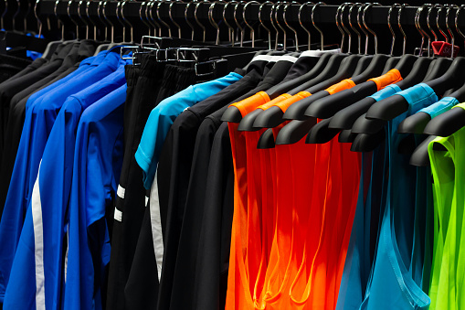

Gavin Ayers

Table of Contents

Section A: The Marketing Environment
- Current Trends in the Industry
- Industry Potential
- Acknowledgment of Competitive Factors
- Acknowledgement of Technological Factors
- Acknowledgement of Political/ Legal Factors
- Acknowledgment of Social/ Cultural Factors
- Decision Making Factors – (A.K.A Consumer Behavior Factors)

Section B: The Competitive Analysis
Competitor #1: Lululemon
- Positioning Map
- Primary Target Marketing Analysis
- Customer Experience Analysis and Strategic Examples
- Pricing Objective, Analysis and Strategies Discussion
- Compare products
- Pricing objective
- Existing Price Analysis & Strategies
- Place Analysis and Strategies Discussion
- Non-Digital Promotion Objective(s), Analysis and Strategies Discussion
- New/ Acquisition Strategies
- Existing Customer Strategies
- Analysis
7. Digital Promotion Objective(s), Analysis and Strategies Discussion
- New/ Acquisition Strategies
- Existing Customer Strategies
- Analysis

Competitor #2: Vuori
- Positioning Map
- Primary Target Marketing Analysis
- Customer Experience Analysis and Strategic Examples
- Pricing Objective, Analysis and Strategies Discussion
- Compare products
- Pricing objective
- Existing Price Analysis & Strategies
- Place Analysis and Strategies Discussion
- Non-Digital Promotion Objective(s), Analysis and Strategies Discussion
- New/ Acquisition Strategies
- Existing Customer Strategies
- Analysis
7. Digital Promotion Objective(s), Analysis and Strategies Discussion
a. New/ Acquisition Strategies
b. Existing Customer Strategies
c. Analysis

Section C: Timeout
- Ethical Issues & Action Plan
  - Hypothetical Issue
  - My Tension
  - Two Biblical Principles
  - Action Plan
  - Rationale
- S.W.O.T. Analysis
- Competitive Advantages
  - State 5-7 problems found from research
  - State solution with examples and cited research
- Internal Marketing Strategies for 3rd Product
  - Systems of Quality & Consistency
  - Employee Satisfaction & Training
  - Research Systems
- Creating Options

Section D: Third Business
- Positioning Map
- Primary Target Marketing Analysis
- Customer Experience Analysis and Strategic Examples
- Pricing Objective, Analysis and Strategies Discussion
  - Compare products
  - Pricing objective
  - Existing Price Analysis & Strategies
- Place Analysis and Strategies Discussion
- Non-Digital Promotion Objective(s), Analysis and Strategies Discussion
- New/ Acquisition Strategies
- Existing Customer Strategies
- Analysis
7. Digital Promotion Objective(s), Analysis and Strategies Discussion
a. New/ Acquisition Strategies
b. Existing Customer Strategies
c. Analysis

Section E: List of Works Consulted
Section A: The Marketing Environment


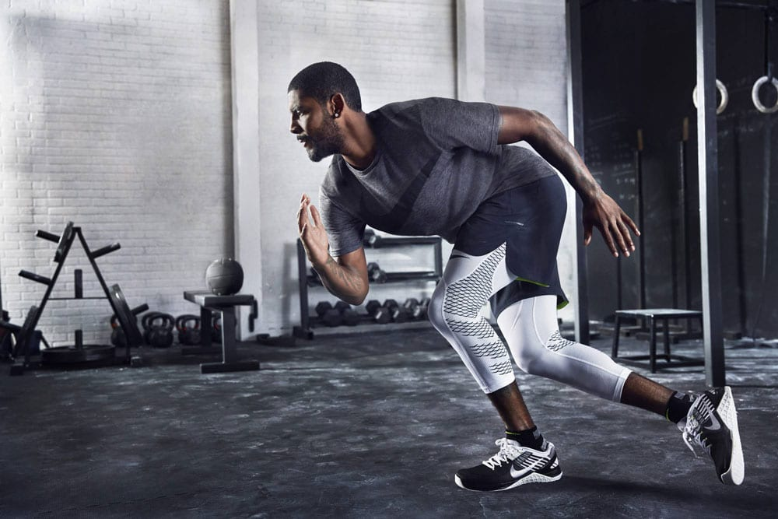
A1. Current Trends in the Industry

A very important current trend in the fitness clothing industry is that a lot of companies are focusing their brand on “Athleisure.” Athleisure is a way for a person to wear an athletic clothing brand and not only it be comfortable, it also is something you can wear for a casual look (PI #6, 9; CI #1, 2, 3, 4, 5, 7, 17). Almost all fitness clothing industries are starting to do this, because it expands the options for consumers to wear their products. Marketers aren’t in the need now to just sit on the idea of making products just for fitness. They are able to do both now. Companies now can have multiple departments in their store, based on the variety of items they make. Fitness clothing stores now are able to make their products based on a certain look people are going for. (WS #1, 2). The fitness clothing industry just doesn’t seem to be forcing only fitness attire, they have found a way to focus on “athleisure.”

In the fitness clothing industry, the showing of diversity is also on the rise. Fitness clothing is a huge industry for diversity, because of needing almost an exact fit if you are wearing the clothes for any type of activity (CI #5, 9, 12, 14, 15, 20). Fitness clothing companies have started to show growth in making more sizes available and not just making a “small, medium and large.” Fitness companies now have been adding true sizes that are numbered and can give an exact fit (CI #4, 5). Sizes aren’t the only diversity that is growing in the fitness industry, another sign is the products made for different activity. Items such as leggings, can be made for biking, yoga, and running. The products are all made for a certain activity that you are looking to do, in order to get that perfect form of comfort that you are wanting (WS#3; CI #1, 2, 3, 4, 5, 7, 17). Fitness clothing industries are now able to grow in their diversity, by providing so many options inside and out for the consumer, where they don’t ever have to second guess what they are purchasing.

Another current trend that I have found in the fitness clothing industry is the use of social media. The reason for this is because everyone these days are now on their phones and online and it is the easiest way to reach out to customers. Social media is a trend for the fitness clothing industry because of how easy it is to reach customers (WS #1, 2 19). For example, Lululemon has around 4 million followers on Instagram and one post reaches out to all of them. In order to keep up with these trends companies in the fitness clothing industry need get a start on social media.

Since many people in our generation are so focused on getting perfection, this has shown me that finding a product for each form of wear comes with some sort of diversity, so the customer doesn’t ever have to guess what they are purchasing. This has also shown me that consumers in today’s world are on a hunt for being comfortable, but still looking stylish while doing so (PI #6, 9; CI #1, 2, 3, 5, 7, 17). By creating a product that gives you that comfort feeling, while looking your ultimate best, it can make your company stand out since that is one of the biggest trends out right now. This can also provide a customer to get a very relaxed shopping experience, because there will always be a certain product that is going to fit them the best.

Implications:

A fitness clothing industry that is always on top of current trends in society are always going to be in the competition or even ahead of it, because they are able to always keep up with appealing a customer. When a company is aware of a trend they know how to make a slight adjustment to products where it will catch the eye of the consumer. An effective way for myself to keep up with current trends for my third business is simply doing research periodically in order to never miss a trend going on. It is also very important for me to be aware of my competition, if my competitor is aware of these current trends and I am not it will make me take a huge step back and them a huge step forward. By being diverse and giving customers “athleisure” it will have them in the current trend going on and not keep them falling behind competitors who are doing the same.

A2. Industry Potential

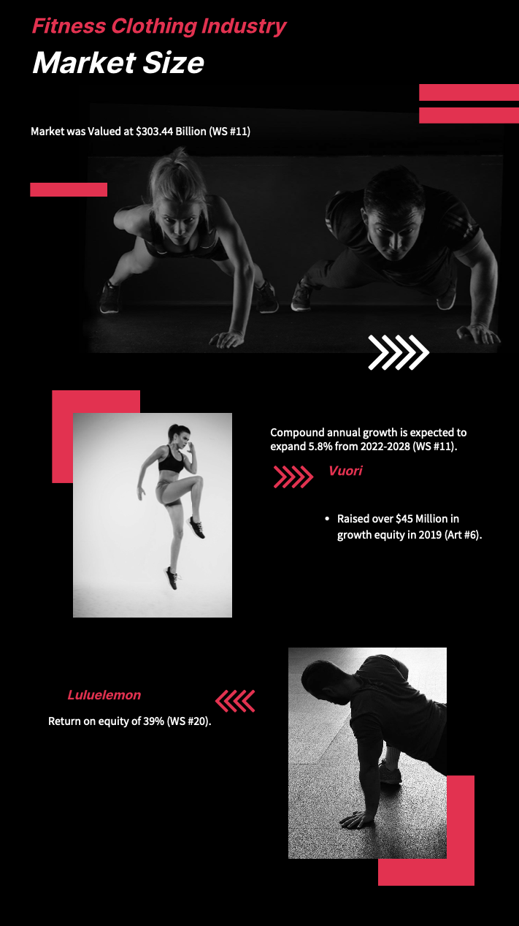

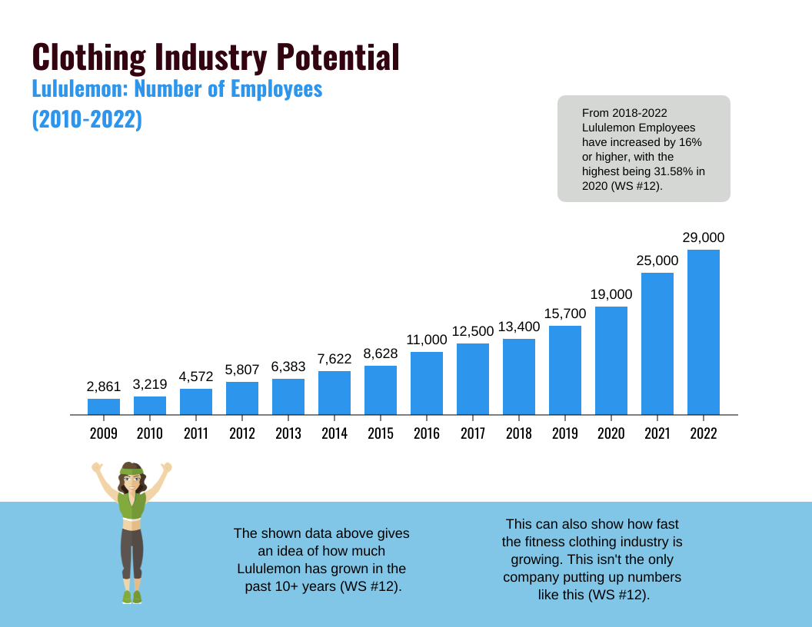
In 2021 the fitness clothing industry market size was valued at $303.44 billion and is still expected to expand at a compound annual growth (CAGR) of 5.8% from 2022-2028 (WS #11). This industry has so much room for growth with the amount of change that has come in the recent years. Fitness clothing has changed to be worn as casual look, and not only in the gym. This industry is a worth the investment because of the rapid growth that it shows to make. For instance, a new upcoming company that started in 2015 named “Vuori” has shown a tremendous amount of growth. Lululemon is showing 39% return on equity, which shows how much they ae making over their break-even point (WS #20). Vuori has raised around $45 million in growth equity in 2019 (Art #6). This shows that even a brand-new company can have success in the fitness industry with already so many competitors by knowing the market.

The fitness clothing industry will always be relevant in society because fitness is something that will never go away. Wearing your fitness clothes overtime they are going to get worn down at some point because they aren’t going to last forever, so it shows that there will always be a need to get more (WS #11). Another example that is huge for the growth of fitness clothing industries is expanding their products. For example, Lululemon created a “MIRROR” where you can work out in front of it, while it has a trainer there for you (Art #7). Companies like Lululemon are providing more options so when someone buys this mirror they are going to need clothing to work out alongside of them, which again creates another cycle of buying more clothes. This will always be good for companies because they know that customers will always be making their way into their store looking to buy more clothing.

Lululemon has shown one of the biggest outcomes in the fitness clothing industry in recent years. The reason for this is how well they put out jobs for employees and train them to be knowledgeable and happy at work. Lululemon has grown from 2,861 employees to 29,000 in the last ten years (WS #12). From 2009, when Lululemon was a smaller company showed an increase every year in hiring employees. It shows how well their potential was and they knew this. This shows us how fast the fitness clothing industry is growing as well (WS #12). Lululemon also puts out numerous amounts of products that can be worn for casual and fitness, with make them stand out as well.

The fitness clothing industry has a big impact on society by providing many job opportunities. With the industry growing rapidly it has caused a need for workers especially with how many new fitness clothing companies there are now. From 2018- 2021 Lululemon employees have increases by 16% and higher each year, with the highest being a 31.58% increase in 2020 (WS #12). The growth in just this one company alone, shows how much need there is in the fitness clothing industry. Another example would be Nike, as of May 31, 2022 Nike employed approximately 79,100 workers worldwide (WS #13). With how well these companies have been expanding it has created so many job opportunities to get into the fitness clothing industry.

Implications:

By understanding the fitness clothing industry and the potential growth it has, when I am opening up my third business I come with much knowledge and confidence that it will succeed. Seeing the numbers that I provided in this section I noticed how well this industry is doing especially some of the big named companies. When looking into the potential of the industry it might be stressful at first wondering how I can compete with these companies, but by knowing where the potential lies, I will be right there with my competition. The big numbers above provide me with a high outlook on where my company could be in a couple years.

A3. Acknowledgment of Competitive Factors

There are many competitors in the fitness clothing industry because of the high status that some fitness clothing companies have already established. These well-known companies have done a good job of cresting customer loyalty and has been a major part of their success (CI #8). The fitness clothing industry can make it hard for customers to shop exactly for what they are looking for, which has made some companies stand out from the certain products they have for any activity that you are looking for (CI #3, 4, 5). These companies have made a way of creating “fans” in order to have customers stay loyal to them (CI #4). Since building fans for these companies has been such an impactful way to create long-term companies, then new companies that are looking at ways to grow their business will need to try and do the same.

The two direct competitors that I will be looking at in my project is Lululemon and Vuori. These two competitors are both on the rise; Lululemon has made a big name for itself by blowing competition out of the water recently, but the other company that I am looking at which is Vuori is on a huge come-up especially with the numbers they put up for being a newer company. For companies to be able to compete in this industry they will need to come up with certain strategies in order to gain lifelong customers. Building a fan base will be a huge strategy for this industry.

Other Direct Competitors:
- Nike
- Under Armour
- Alo
- Athleta
- Fabletics
- Gymshark

All of these companies listed as “other direct competitors” have realistically the same goal in mind which is selling strictly fitness clothing. Many of the companies have moved onto selling other fitness attire or products, but in general the main products are clothing. They sell everything in regards to shorts, t-shirts, sweatshirts, sweats, leggings, socks, underwear and more. All of these companies sell generally the same products, but each company has a way to put their own spin on the product, which is their way of standing out to the others. Since the companies are all going after the same target market having a spin to their product is what is going to make them get their own customers instead of them shopping with their competitors.

Indirect Competitors:
- Dick’s Sporting Goods
- Big 5
- Target
- Costco
- Walmart
- Amazon

The companies listed as “indirect competitors” are different from direct competitors because they may have some items that are listed in the fitness clothing industry, but it is not their main focus of products. For instance, when you look at Target they have a whoel clothing section with maybe only 10 different fitness clothing items, but the overall store focus is having everything, such as TV’s, food, healthcare items, and toys. This is what makes them an indirect competitor because they don’t have to sell just fitness clothes they are able to sell more of everything.

The fitness clothing industry has been growing rapidly because of everyone’s want of comfort while working out. The fitness clothing industry has expanded all throughout the world because of the growth it has been making (Art #4). With how well this industry has been expanding it is a great opportunity for a new business to pursue this industry, while it is on a high-rise.

Implications:

By understanding who my direct and indirect competitors are it will provide me with the knowledge I need for starting up my third business. These competitors will show me what they have been doing well for the industry and it will be a way for me to get a better understanding in order to build my fanbase. In order to standout from these competitors my clothing brand needs to have a spin on the product. My direct and indirect competitors have also shown the ability to stay on top of current trends, and it provides me a way to see their success from it and engage my company to do the same. With how my direct competitors have done in the industry it makes me want to go out and get more research in order to be right in the competition when my company opens up from day one. I feel that if another company has been able to start up and blow through competition why can’t mine do the same.

A4. Acknowledgment of Technological Factors

With how well technology has been growing in society, it is only necessary for the fitness clothing industry to keep up to date with it as well. Fitness clothing companies are having to keep up with current technology in order to stay with the competition. A good way to do this is by finding new unique strategies in order to incorporate technology into your business. By keeping up with technology customers are going to get the best experience possible with your company. It makes the process so much easier for them and gives them a quality shopping experience.

One way that I could see technology benefiting the fitness clothing industry is having a system on a mobile app where customers can try on a piece of clothing virtually. A way you can do this is setting up your phone and having the camera faced to you and pick whatever item of clothing you want and the app will place it on you so you can see if you like the color, and product. This would be very beneficial because it saves the customer the hassle of getting in their car and going to the store and seeing if they even like the product. This gives the customer convenience and a fast-paced shopping experience, which in today’s world is much needed (CI #1, 5, 8).

Another way I can see technology benefiting the fitness clothing industry is having a place on either their website or mobile app where athletes or even regular customers can post physical data on how they move in certain activity. This could be called “smart clothing” there could be a system in the clothing where it can provide data of how the piece of clothing can help your activity in whatever type of fitness you are going into (WS #14). By incorporating smart clothing, it can provide instant feedback of how the body moves in the clothing. This could be huge for a company because the data could come back with great feedback. For instance, it can help show data of protecting against injuries, progress in practice, and even a way of coaching (WS#14). This smart clothing can import a whole new world of fitness clothing because it wouldn’t just be activewear, now it can track an entire workout and how your body can move.

In order for fitness clothing companies to be successful with technology they need to be up to date in what is changing in society. Since technology is growing at a rapid pace, companies need to be able to incorporate it into their products to stay in the competition. Technology is the best way to give customers a fast shopping experience, which is a must need in today’s world. Customers also love instant feedback and that’s why I feel smart clothing could be a very unique tool in products.

Implications:

I feel it is very important for a business owner to be aware of the constant changes of technology. I feel that with knowing the changes of technology it will help you change your products to the customer’s needs. By changing your products to the customer’s needs and finding something new that hasn’t been introduced it will keep you in the competition and surpassing it. When you can find something new that a customer has never seen before, it makes the consumer want to come and try out the product. This will always lead you to getting new customers into your store and it will also help you keep long-term customers as well. Technology is a huge factor that is always needed in the fitness clothing industry.

A5. Acknowledgment of Political/ Legal Factors

In the fitness clothing industry, it is really easy for companies now to counterfeit products because clothing can be so simple that it is really easy to copy. A lot of brands find a product they like from a big company and find a similar product and just slap their own logo on it (Art #9). Some known consequences that can happen for counterfeit products are huge losses to both buyers and sellers of the original products, and fake products can result in health hazards, loss of image and slow growth (Art #9). With the growth of social media, it is so much easier for companies to advertise similar looking products to higher end companies to attract customers and getting an easy buy. According to Ghost Data, 20 percent of fashion clothing products advertised on social media platforms are fake (Art #9). This just shows how easy it can be to interact with a fake product and not even realize it.

Another common challenge in the fitness clothing industry is the affect that it can have on the environment. To produce clothes, it can usually take a pretty big tole on the environment because clothing is needed everywhere and it will never go away, but there could be some liable outcomes from doing this. Clothing being made is responsible for 10% of human-caused greenhouse gas emissions and 20% of global wastewater, tends to use more energy than aviation and shipping sectors (Art #10). The impact that clothing being made has on the economy is never ending and can be harmful in the long-run. A big example of this is the wasted water that they use in order to make the products. The clothing industry as a whole consumes 93 billion metric tons of clean water each year (Art #10). This is a perfect example to showcase how much they use because Americans drink about half of that in a year. It shows that the water being used can lead to waste and in the long-run hurt the environment.

The fitness clothing industry can be very harsh on work environments as well. Since clothing has been getting so cheap to make it usually makes the people working in tough environments. With the rapid growth of the fitness clothing industry products are in need to be produced faster than ever. This for example makes the companies dependent on exploited labor force in developing countries where regulations are lax (Art #10). Work environments can be extremely harsh and also barely provide a living for some of these workers. For instance, 75 million factory workers around the world, estimates that only 2% earn a living wage (Art #10). Only 2% of the 75 million workers can live off that job alone, while they are most likely working long hours and hard labor.

Implications:

As a new business owner in the fitness clothing industry, it is very important for me to be aware of political and legal issues. I must be on top of research of these problems going on in the fitness clothing industry. If I am not on top of my research and these factors start happening in my company it could lead my business to loss in money and even to be shut down. In order to be aware of political and legal factors I must know how to make products that are sustainable. In order to keep sustainability, I need to create authentic products and not base them off of other companies. This for example looks like a product that has its own unique twist to it that other competitors haven’t created or seen before. I also need to make sure the products I am making aren’t hurting the economy and our products aren’t going to waste. The last challenge that I need to face as a new business owner is making my work environment a safe place and providing good pay to employees working the hard labor jobs. I know that in this political and legal factors sections that as a business owner there are going to be no shortcuts or it could lead my company to disaster.

A6. Acknowledgement of Social/ Cultural Factors

In order for a company to be successful they need to be aware of social and cultural factors. When companies are aware and up to date on the economy it can help them be in good need for them. A huge benefit that the fitness clothing industry can have on society is by donating money to certain causes. This for one can make a company look good because they are giving back to society and it also shows that they care about the society and impacting others. When companies are able to donate to certain causes in society it is a good way for them to build trust and loyalty with their customers as well. (WS #1, 2, 9). This gives them an opportunity for customers to see that they care about others and not just being money hungry. This will help customers become long-term because they know they will be getting a good experience with a company who cares (CI #8).

Another impact that social and cultural factors can have on the fitness clothing industry is the fast-paced society that we live in today. Many customers want to have the fastest shopping experience possible. It is so easy and convenient for companies now to have in-store pick up where customers can order exactly what they want online and pick it up immediately instead of digging through clothes in the store (CI #5). Especially with the fitness clothing industry when it can be very time consuming finding the perfect workout attire, it gives you time to sit at home and scroll on your phone to find the perfect product you were looking for (CI #5). Customers are always wanting convenient shopping so I feel this is a viable option for them.

Social and cultural impacts can also be looked at by helping better the environment. A good way for them to do this is by “going green.” A lot of companies now are finding ways to make products that are easier to recycle. Patagonia is one of the biggest companies known for doing this. Patagonia may not be a fitness clothing brand, but they are doing some really cool things in order to practice social and cultural factors. Something that I found interesting is how they send employees on a paid leave to go take a trip for a month, but it has to be a form of outside activity (Art #3). These trips must deal with the environment and the reason they do this is so the employees can understand the environment and why Patagonia does what they do, it can help the employer grow their knowledge as well (Art #3).

Implications:

Starting up my third business I have to be aware of social and cultural factors. I need to be aware of this because in order for my business to be successful my customers are going to need to see that I care about society and not just in this for the money. In order to do this, I need to be donating to certain causes that can be either related to the fitness industry or even to anything that can be impacting to society. Also, by staying up to the fast-paced environment we are living in now it will guarantee my customers a convenient shopping experience. Once I do all this I can dig deeper into my products and make sure that they are going to be safe for the environment and find ways to change and adapt to certain changes in society. By staying on top of social and cultural factors I will be able to gain trust with my customers and gain long-term satisfaction.

A7. Decision Making Factors – (A.K.A Consumer Behavior Factors)

- Comfort to Wear (PI #6, 9; CI #1, 2, 3, 4, 5, 7, 10, 11, 14, 17)
- Vibe Setting (PI #3, 7, 8, 9; CI #2, 4, 8, 9, 10, 12, 13, 21)
- Convenient location (WS # 1, 2, 15, 16; CI #8, 9, 10, 12)
- Employee Friendliness (CI #3, 5, 8, 9, 12, 15)
- Employee Knowledge (PI #2, 4, 7; CI # 4, 5, 8, 9, 10, 14, 20)
- Availability of Ambassador Programs (WS #1, 2; PI #9; CI #29, 30)
- Affordable Prices (PI #6, 9; CI #1, 2, 4, 10, 11, 14, 15, 17)
- Line Wait-Time (WS #17; PI #9, 10; CI #21, 23, 24)
- Environmental Friendly (Art #3; CI #4, 16)
- Premium Materials (PI # 6, 9; CI #1, 2, 3, 4, 5, 7, 16, 17)
- Accurate Sizing (WS #3, 10; CI #4, 5)
- Product Stability (CI # 4, 10, 11)
- Clothing Availability (PI #8; CI #1, 3, 14)
- In-Store Pickup (WS #1, 2; PI #9; CI #5)
- Store Promotions (WS #1,2, 5, 6, 7, 8, 9, 10; PI #9)

Implications:

As a new business owner being aware of decision-making factors is very important for a successful company. The reason for this is companies have to be up to date on what customers are going to be looking for when coming into my store. By having these decision-making factors, it will make me research each one individually and find what ones will help benefit my specific business. The reason to do this is to make my priorities set in different areas so that no matter what customer comes in I can be able to satisfy them for whatever need they are looking for. All of this can help give the customer an easier shopping experience and fill a need that they came in looking for.

Section B: Competitive Analysis
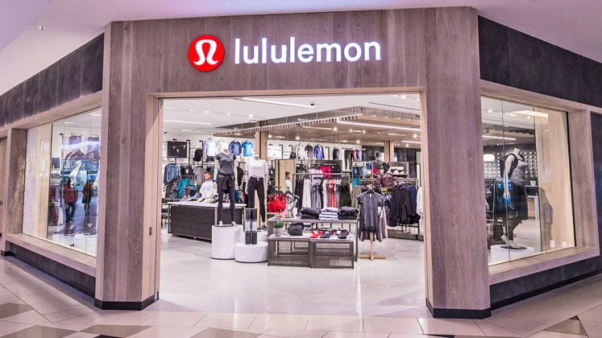
Competitor #1 Lululemon
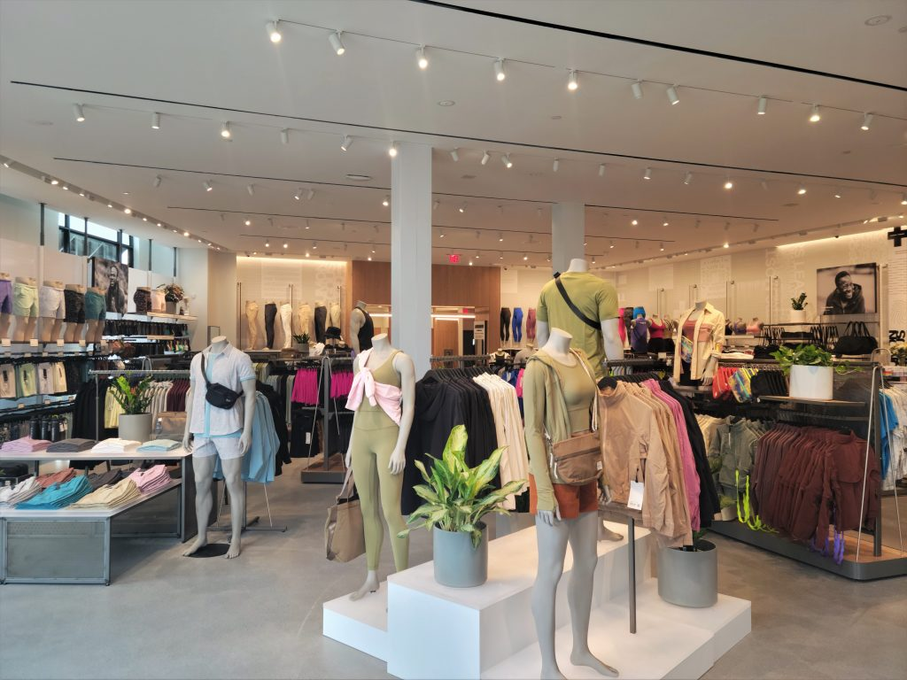

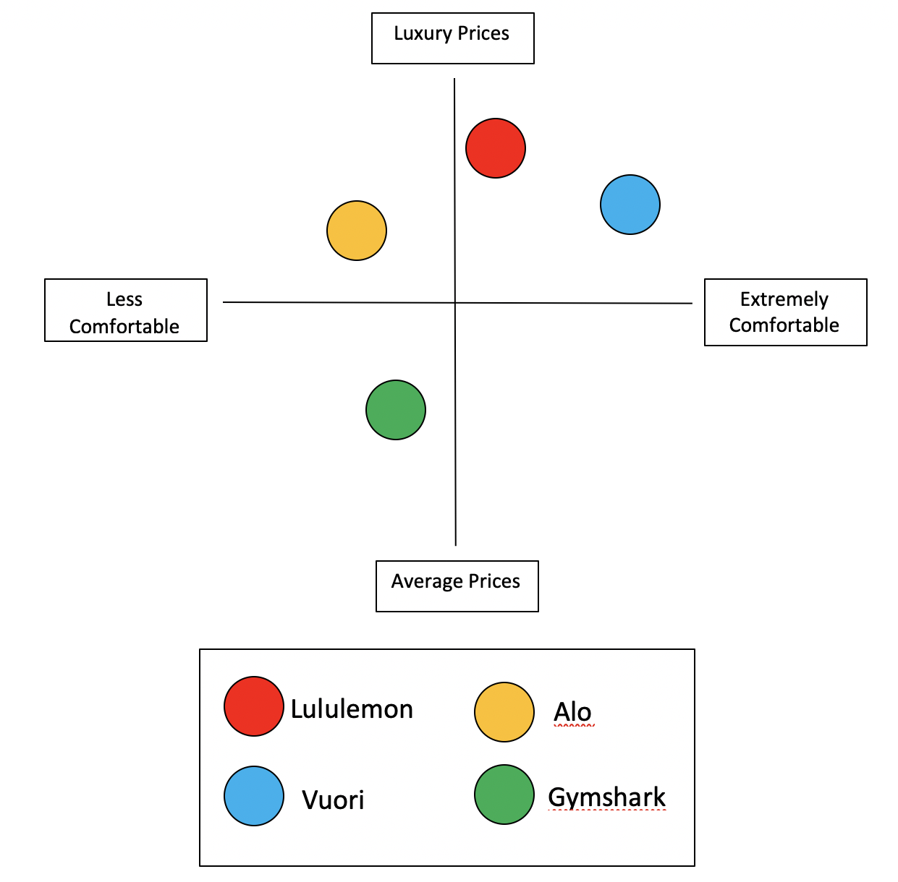
B.1 Positioning Maps
Why? After doing my interviews and research I ended up placing my competitor #1 Lululemon in the top right quadrant. I placed them in the top right quadrant because they have shown to have a luxury price, but with that price comes extreme comfort (PI #6, 9; CI #1, 2, 3, 5, 7, 17). When doing these interviews, I found out that customers weren’t complaining about the priced, because they knew that the products they were buying were based off the quality. They always felt like the purchase was worth it because they knew the quality would last them a long time (CI #5, 7). The quality of the products was always really good for the customers workout activity that they wanted to wear it for.
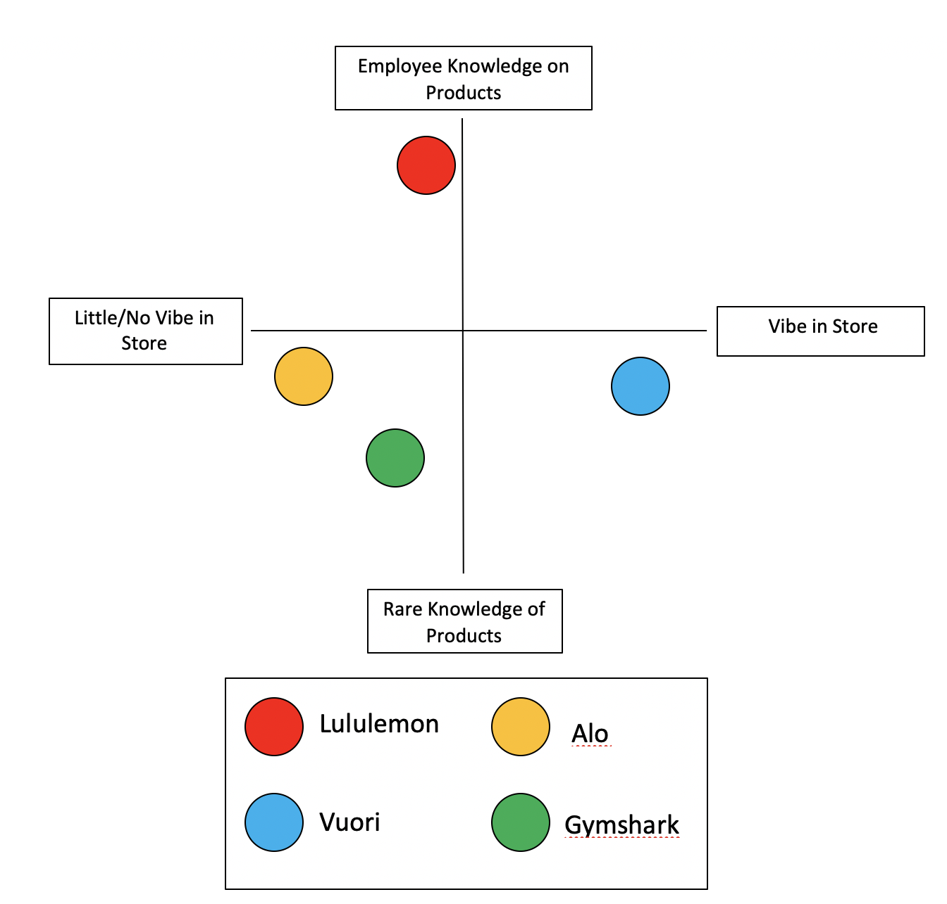
Why? After reviewing my research and doing my interviews I decided to place Lululemon in the top left quadrant. The reason I put them in the top left quadrant is based on how well their employee knowledge is because of the brands success it shows how important this can be (PI #3, 8; CI #5, 14, 20). Lululemon has employees who have shown to help customers decide on proper outfits for the certain activity they are planning to do. The other reason Lululemon was placed in the upper left quadrant is because of their vibe in the store. It doesn’t have a unique vibe, it is mainly just working fitness activity, but it isn’t as unique because it is so broad (PI #3, 8, 9; CI #2, 13). The music choice they play has actually stood out to some customers that I interviewed, which I haven’t seen in any of the other stores I have interviewed (CI #3). They have a vibe of working out and staying active which is why it isn’t placed as far left as some of the others.

B.2 Primary Target Market Analysis

Primary Psychographic:

Psychographic is the most important for Lululemon because they target customers who are focused on all fitness activity.

Why?

Lululemon has shown many ways of how they know their audience and how they are able to attract them into their stores. Lululemon has more of an athletic vibe to their store and it isn’t necessarily unique, but it is still very appealing to the customers eye. Customers have noticed the vibe of the store to be very passionate for customers who are interested in fitness activity (PI #3, 8, 9; CI #2, 13). The employees at Lululemon have also shown that they have a love for fitness, from what they wear and the way that they have expressed their personality. The employees are also part of Lululemon’s way of setting a vibe, since they hire people who have a passion for fitness it is an easy way for them to showcase that to their audience and attract more customers into the store.

Primary Demographic:

Lululemon is a well-known company who has made a name for themselves over the years and it will draw in customers. However, Lululemon is focused on targeting people who have a passion for fitness. They target more of an upper class and in the range of 18-35 years old.

Why?

Lululemon has found a perfect target market for themselves and it has shown to work out for them. Even though Lululemon is on the more expensive side, they know that customers who want products that benefit their fitness activity they will pay the price for long-term quality (PI #6; CI #1, 2, 3, 5, 7, 17). Lululemon has found ways to focus on customers who are focused on fitness and that is what will get them to come into their store. Lululemon doesn’t have a unique twist to their products, they just mainly focus their product on customers who are looking for fitness products. They are still able to sell their products because of their well-though demographic.

Primary Benefits:

The primary benefits of buying Lululemon is knowing that you are going to be purchasing a product that is going to have great material, which has been made with dedicated work. Lululemon also offers a product with comfortable materials and something that will last you a long period of time. They can also provide a casual look, and not be strictly for fitness activities like most fitness apparel companies.

Why?

When looking at Lululemon you can instantly notice how much time and effort they put into their materials. You can see the hard work through the unique designs they use for their products and the variation of materials for all different types of fitness activities a customer wants to use them for. When feeling the products, you can feel how durable they are and the quality of materials that they used to make their products (PI #6, 9; CI #1, 2, 3, 5, 7, 17). Customers will benefit going into Lululemon because they don’t necessarily need to be looking for just fitness clothing, almost all of their clothing can be used for casual wear as well, which makes them standout (PI #9). Even if a customer is just coming in to look around the store they will feel welcomed by the fitness atmosphere.

Primary Geographic:

Lululemon has a strong geographic ahead of them and have expanded throughout countries in the past couple of years. Since, the company is now recently starting to expand the last couple years is why I have their geographic last.

Why?

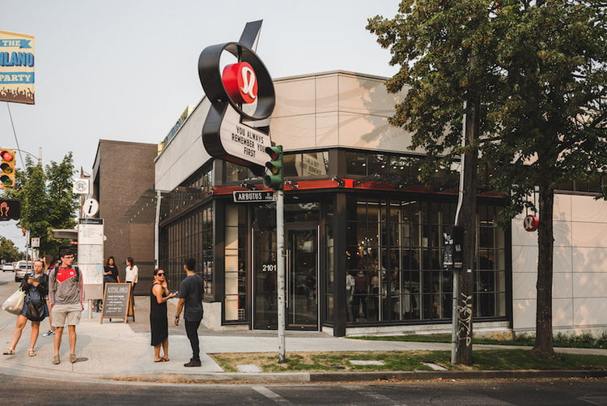
Lululemon has made a strong name for themselves and have expanded all over the world to grow their brand. Starting off in Canada the company started to grow so they opened up stores in the United States. Lululemon has 324 stores in the United States, 86 in China, and 63 in Canada and many more in other countries. (WS #18). Lululemon is mostly seen in malls, because of the high foot traffic that comes in and out of the store. The name of the store brings people in because of how much they have grown and the name they have made for themselves (PI #9). Lululemon has made stores that are not in malls of most of their stores you will see in malls because they know that most of the time customers will come to them first because of the name they built for themselves in this industry.

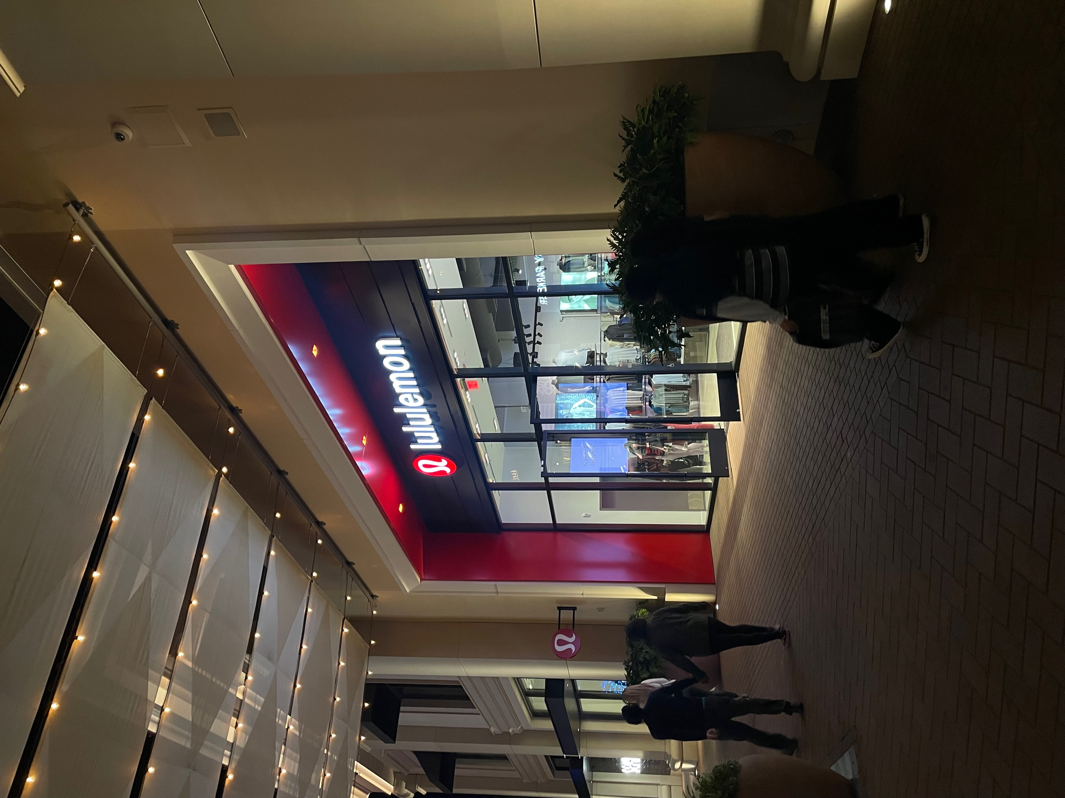
B3. Customer Experience Analysis and Strategies

Customer Experience Objective:

The primary goal of Lululemon in order to give the best customer experience possible is by having a good vibe in their store, providing products that are comfortable to fit their athletic activity, hiring employees who love their job and serve customers at a high value, also employees that are knowledgeable (PI #6, 9; CI #1, 2, 3, 5, 7, 14, 17, 20).

Customer Experience Analysis and Strategies:

Lululemon has done a good job of finding ways to bring an all-around customer experience to consumers. Lululemon has done a good job of this by setting an atmosphere that makes customers want to come into their store and feel at home (PI #3, 8, 9; CI #2, 13). Lululemon has made their store very unique in order to get customers into it and get a proper experience. A way that they did this was by playing good music in their store (PI #9; CI #2). Playing music that draws a customer’s attention is a really good way to make them feel at home and be satisfied when shopping at this company. This makes a customer feel comfortable when shopping and not feel out of place when coming into their store. Another way that Lululemon has shown a good vibe in their store is all of the workout decorations that they have. This is also really appealing for the customer because most people who go into Lululemon come in to look for workout clothes. By having fitness activity decorations, it really can make a customer feel at home when coming into their store and leaving a customer satisfied.

Lululemon doesn’t necessarily have a unique style to their fitness clothing, they make their products good for all activities of fitness. Most fitness clothing brands direct this to one part of fitness, but Lululemon has found a way to hit all types of fitness, which makes a customer experience even better when coming into their store. This has also helped prove how well the employee knowledge and will to help as well (PI #3, 8; CI #5, 14, 20). The employees at Lululemon are generally all interested in fitness and have some sort of background. This makes it easy for the employees and customers to have an easy interaction and relate on the same level. This helps give a good customer experience by setting a good vibe in the store, making sure employees are knowledgeable and wanting to be there, and also providing a good quality product for the customers to enjoy.

Lululemon has also shown to do a successful job of showing love for the community and bringing a good customer experience through that. A big way of doing this for Lululemon is impacting the environment and making products that will help better it than destroy it. Lululemon is adopting practices and creating solutions that enhance products, minimize negative impact, and contribute to restoring the environment (WS #1). Lululemon places to innovate more sustainable materials, create circularity through new guest models and use less water (WS #1). Each of these three categories Lululemon states have a plan going into 2025 and should all be done around that time and then stay committed to it after. Lululemon wants their materials to be fibers that are recyclable, renewable, regenerative, sourced responsible, and manufactured using low-resource processes (WS #1). Lululemon has taken a big step focusing on the environment knowing that especially in today’s society customers rely heavily on what the company does in order to better the environment. Many customers won’t shop at stores that are hurting the environment and Lululemon is showing strong ways to make sure they are on top of problems going on in society and providing a good experience for their customers.

Customer Experience Strengths:

- Fitness vibe with decorations to show it (PI #3, 8, 9; CI #2, 13)
- Joyful and knowledgeable employees (PI #3, 8; CI #5, 14, 20)
- Environment friendly products (WS #1; PI #9; CI #26)
- Comfortable products (PI #6, 9; CI #1, 2, 3, 5, 7, 17)

Customer Experience Weaknesses:

- Prices tend to be expensive (PI #6; CI #1, 2, 3, 5, 7, 17)
- Employees can lack being helpful (WS #3; PI #9)

B4. Price Objectives, Analysis & Strategies Discussion:

 | Lululemon | Vuori | Industry Average
Athletic Shorts | $58.00-$88.00 | $68.00-$78.00 | $48.00-$88.00
Athletic Shirts | $58.00-$78.00 | $54.00-$74.00 | $58.00-$88.00

Price Objectives:

Lululemon has priced their products around the fitness clothing industry average. The fitness clothing industry and Lululemon especially is more of a high-end of meeting competition because of the high-end costs that their products display. Lululemon has really set the tone for the pricing of this industry. Lululemon has made a name for themselves and have knocked out a lot of competition, so other companies had to keep up with them. Lululemon has shown to make high quality products and this is why they price their products for how they do. Lululemon’s main focus is to target customers who have a passion for fitness and want a high-quality product to wear in whatever activity they are looking to do (PI #3, 6, 8, 9; CI #1, 2, 3, 5, 7, 13, 17).

Pricing Analysis and Strategies:

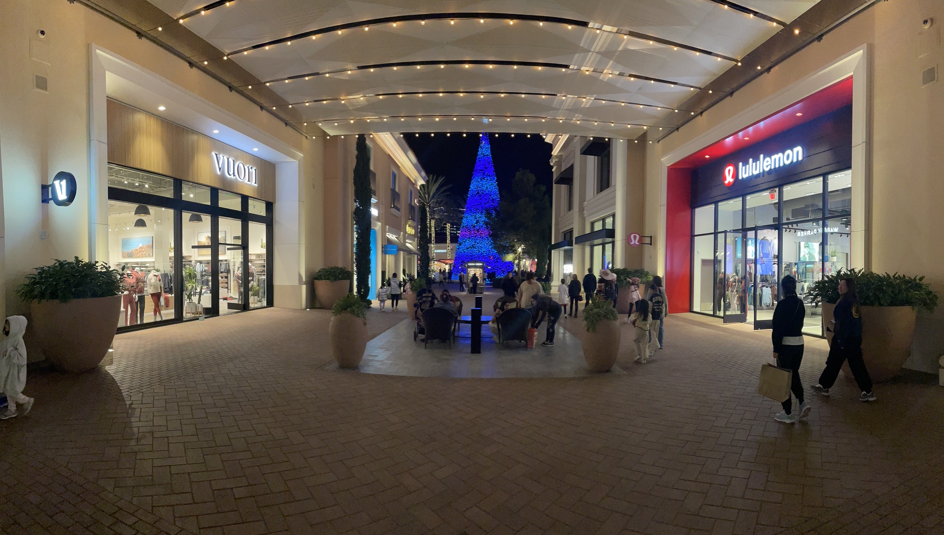
Lululemon has very similar pricing strategies to other companies in the fitness clothing industry. Most of the companies in the fitness clothing industry are high- end because of the materials they use in order to make their products the best possible for fitness activities (PI #6, 9; CI #1, 2, 3, 5, 7, 17). Lululemon doesn’t need to set their prices at the lower end because they know the quality of their materials. They have high quality materials that are comfortable for customers during their workouts so they know they can set their prices high knowing that the customers will pay for how good the material is. Customers will also pay for this product because they know that it will last them a long time as well and don’t have to worry about buying new clothing every month. Lululemon has also shown unique products that catches the customers eye because it can be worn for workouts and casual wear.

Lululemon has done a great job of their pricing strategies by researching their competition and really setting the tone for the fitness clothing industry in general. With the growth of Lululemon in a short amount of time they really set the tone for the fitness clothing industry by making a name for themselves and blowing out the competition. Lululemon hasn’t needed to make many changes to their prices since they set the tone for the industry, most of the competing companies in the fitness clothing industry are the ones having to change their prices in order to stay in with the competition. In the fitness clothing industry, it is hard to sell products at a cheap price because the quality of the material has to be good because in athletic activity you need to be able to move comfortably. For example, if Lululemon lowered their costs by 25% it would put them out of the competition from their competitors. Yes, Lululemon would be making sales still, but they won’t be making much profit because of how expensive it is to make their products. This would lead them to falling behind in the competitiveness of the fitness clothing industry. If Lululemon were to increase their prices by 25% they would be able to get away with it and make even more profit. Lululemon has already set the tone for the fitness clothing industry, so for them if they wanted to raise the prices they could. If they did this they might get bad feedback from customers because no customer wants to see an increase in prices, especially the long-term customers. Since Lululemon has made a big name for themselves in this industry they could get away with it because customers are still going to want their products because of the high quality.

Price Strengths:

- Comfort of products benefit fitness activity (PI #6, 9; CI #1, 2, 3, 5, 7, 17)
- Clothing can be used for both fitness and casual wear (PI #9; CI #3, 5)
- Customers hold high value on product quality (PI #6, 9; CI #1, 2, 3, 5, 7, 17)
- They set the tone for the industry (WS #12)

Price Weaknesses:

- Only targets middle to upper class (PI #6; CI #1, 2, 17)

B5. Place Objectives, Analysis, & Strategies Discussion
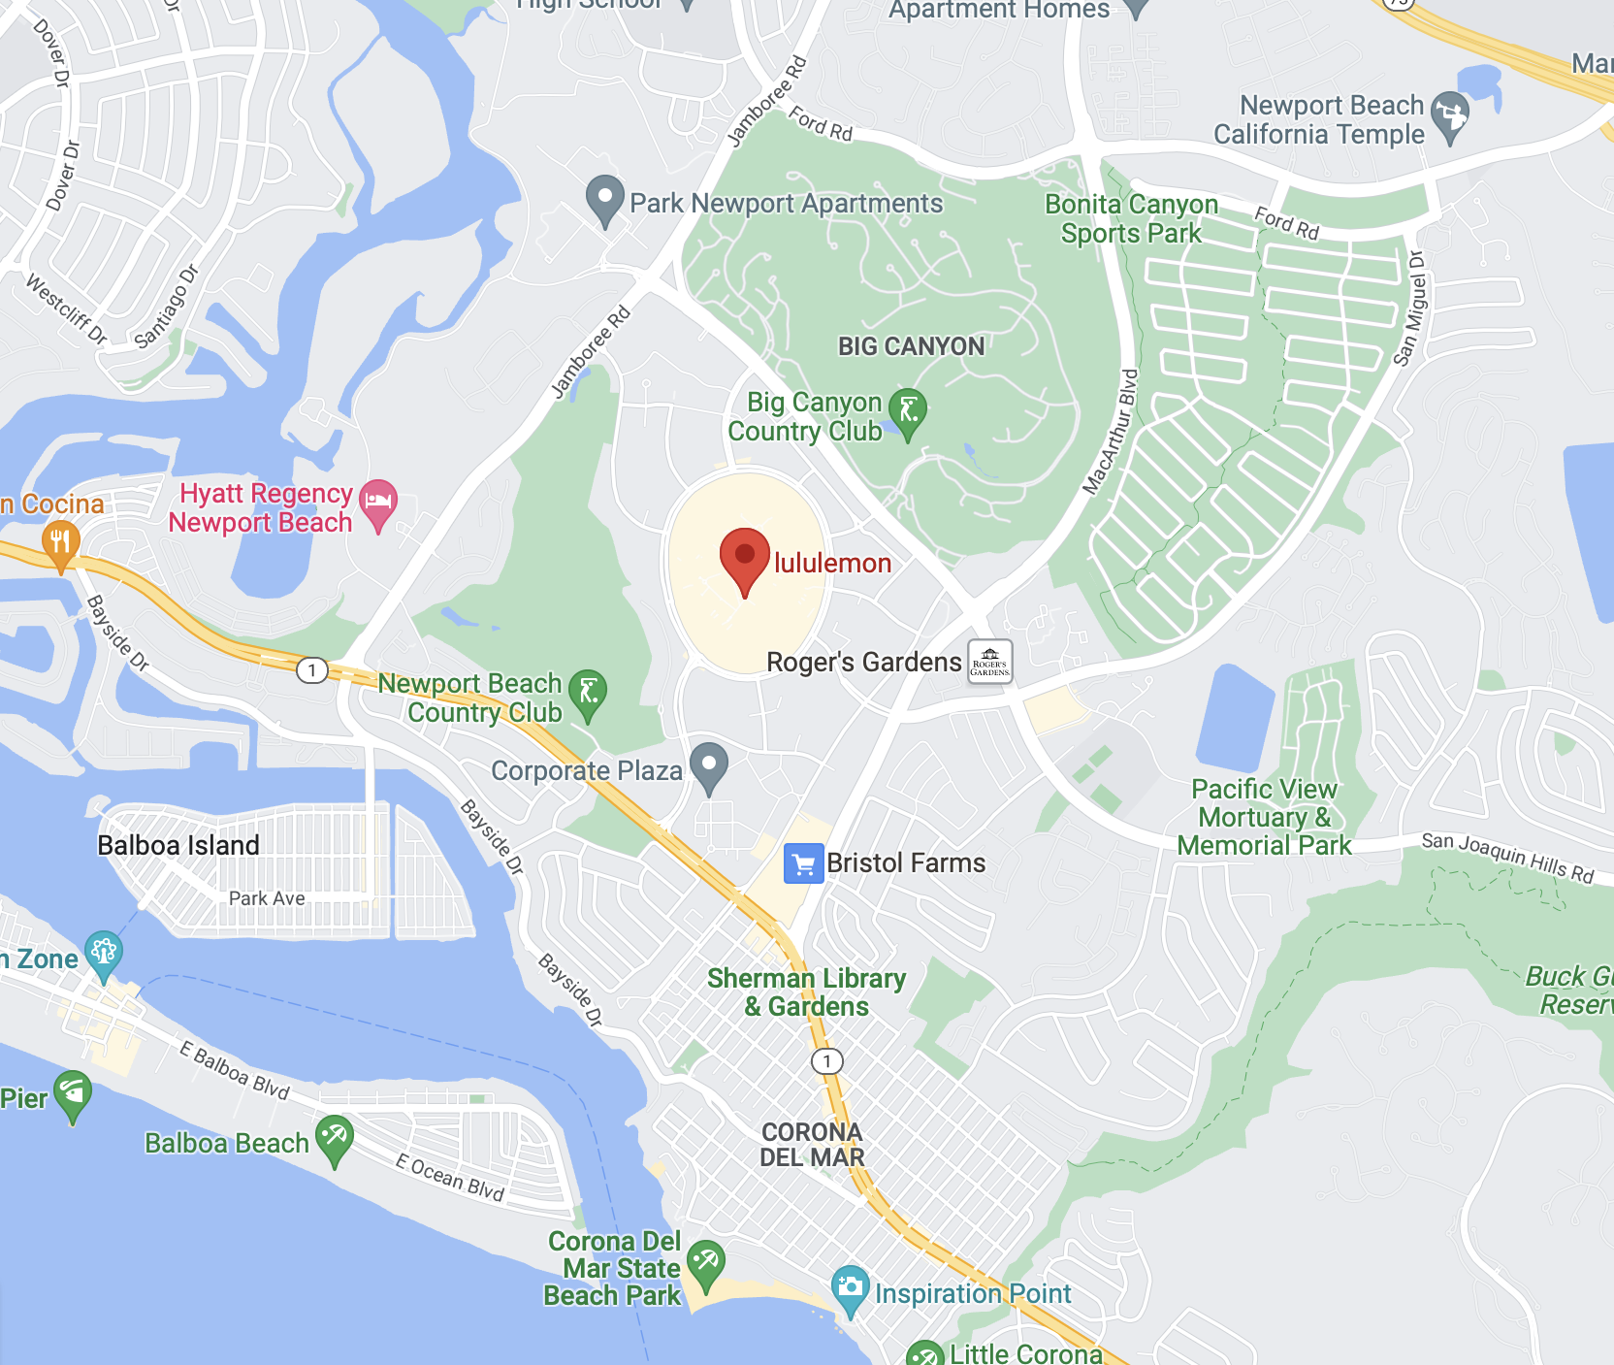

Place Objectives:

Lululemon has worked extremely hard on finding perfect locations for their company. One of my favorite locations that Lululemon has made is their Fashion Island location. Fashion Island is located in Newport Beach, California. This mall has been known for its heavy foot traffics so it is in a perfect location to get customers into their store. Being a well-known company like Lululemon is it is good for them to be located in areas where there will be customers at all time. It is easier for them because customers already know the name of the brand because of their recent success, so their location needs to be in a place where customers can have easy access to get in and out.

Place Analysis and Strategies:

Newport Beach, California is a great location for Lululemon to put as one of their locations because of the heavy foot traffic that Fashion Island brings. Lululemon is usually located inside of a mall, which is good for them because they know that is where their target market is going to be shopping and come into their store the most. Newport Beach is a great location for Lululemon to put one of their stores because it has a population of roughly 85, 249 people and that doesn’t include tourist that come and visit the area (WS #15). By being located in this area Lululemon has an edge over competitors who might not be able to get into as good of a location as this is. Fashion Island shopping center is a very well-known spot for customers to come in to shop because of the stores that they have in their shopping center. Fashion Island attracts roughly 16 million customers a year since 2017 and is still climbing as the population is as well (WS #16). With the number of customers coming into Fashion Island it brings easy attraction to Lululemon because their store is located in a spot where customers can conveniently come in and get all their shopping done in one spot.

The Lululemon that is located in Fashion Island is roughly 10 minutes from the beach making it a very unique location for them. This is a great location for Lululemon because the beach will always be a very high foot traffic area. This is perfect for Lululemon as well because some people do their fitness activity at the beach, whether that consist of walking or jogging (CI #2, 13). Having customers that are regular beach goers and want to have their fitness activity done at the beach it makes Lululemon a great spot for them to do convenient shopping. This is also a great opportunity for customers who don’t own any fitness apparel and want to start getting active, so they will already be in the location and have a place to go.

Lululemon has actually expanded most of their products to specifically target different types. Of physical activity. Lululemon was mainly known for their yoga clothing, but recently have expanded to workout, running, golf, casual, and hiking (WS #1). This is really beneficial because it isn’t just about the location. Just because Lululemon s by the beach it doesn’t have them strictly targeting that they are able to get customers in for all types of activities even if it isn’t just for the beach. Customers are able to come in and find products that are unique for them and not just for one type of fitness activity. Lululemon has shown to place their locations in certain areas, but I have found that they don’t do this because of what is around them, they go where high foot traffic is. All of Lululemon’s clothing have been made for different types of fitness activities and that is why they can locate themselves wherever they want. For example, Vuori is a California based company so they are going to want to be by the beaches because that is what their brand is representing (CI #8, 9, 10, 12). Lululemon doesn’t have to do this so it makes their locations easier to adjust.

Place Strengths:

- High populated area (WS #15, 16)
- Located for their target audience (WS #1; PI #3, 6)
- Able to attract tourists (WS #16)

Place Weaknesses:

- Competitive location since it is in a shopping center (WS #1, 16)

B6. Non-Digital Promotion Objective(s), Analysis and Strategies Discussion

Non-Digital Promotion Objectives:

Lululemon’s main objective of non-digital promotion is to increase their brand awareness and gain long-term customers who love fitness activities.

Non-Digital Promotion Analysis and Strategies:
- New/ Acquisition Strategies:

Lululemon’s main focus for non-digital promotion is through word of mouth (Art #11). Since Lululemon has become a well-known brand over the past couple of years it is easy to say that the word of mouth tactic is strongly working for them. The reason for this is because when a customer first walks into a store they are automatically blown away by the atmosphere of the store. The store is very organized and is appealing to the customers eye (PI #8). Customers come into their store and can see the organized layout they have, which is almost always men on the right and women on the left. This makes it easy for the customer to come in and not feel overwhelmed. The reason this can help word of mouth is because the customers first impression matters the most, since Lululemon is doing such a good job of this customers are left wowed and want to come back and will share that experience with their family and friends. This leads to more customers coming in and also helping them keep long-term customers as well.

Lululemon has done a fantastic job of non-digital promotion by participating in public relation activities. Lululemon has a huge focus on building a community by idolizing healthy lifestyles to center themselves around total mind and body wellness (Art #11). A way that Lululemon does this is running a wide variety of health and fitness events for the brand members. Some of their stores have fitness studios where customers can come in and do workouts and really make them feel a part of the company. They do this because they want to spread their brands values of creating wellness and healthy living. This is very beneficial for them to because with these classes members of their community are always going to be coming in and out of their store because of the classes they provide. Something that Lululemon also does that stands out is the way that they look at their products and how the meaning of their clothing is more of a purchase. For some customers it could be a New Year’s resolution, a fresh start, a return to exercise or even a new way to spend time with their friends (Art #11). Lululemon is doing non-digital promotion the right way by engaging their customers into a healthy lifestyle and wanting to benefit them and not just focused on the sale of a product.

- Existing Customer Strategies:

Lululemon interacts with their customers by having two membership options and a program called the “Sweat Collective.” The two membership options are “Lululemon Essentials” and “Lululemon Studios.” The first option which is their essentials is actually interesting because it is free to join making it easy for customers to get involved with their company for no price. The customers get early access drops, exchange or credit on sale items, select studio content, virtual community events, receipt-free and fast-track returns, and free hemming (WS #1). This is a great option for customers to get their foot in the door with the company and feel like a family, Lululemon wants these customers to reach their goals and are there to help them in any way possible. The next membership option is the studio option. The studio option actually comes with a hefty price tag because their “MIRROR” is required. Their mirror is a self-trainer where customers can buy a subscription and do 10,000 plus world-class workouts from home (WS #1). Other benefits to this are 10 percent off at partner studios, unlimited experiential store classes and early access to events (WS #1). It is smart for Lululemon to give you a free option for the first membership because once customers get their foot in the door and enjoy it they are going to want more and that leads them to purchasing their “MIRROR” and getting more involved with the company.

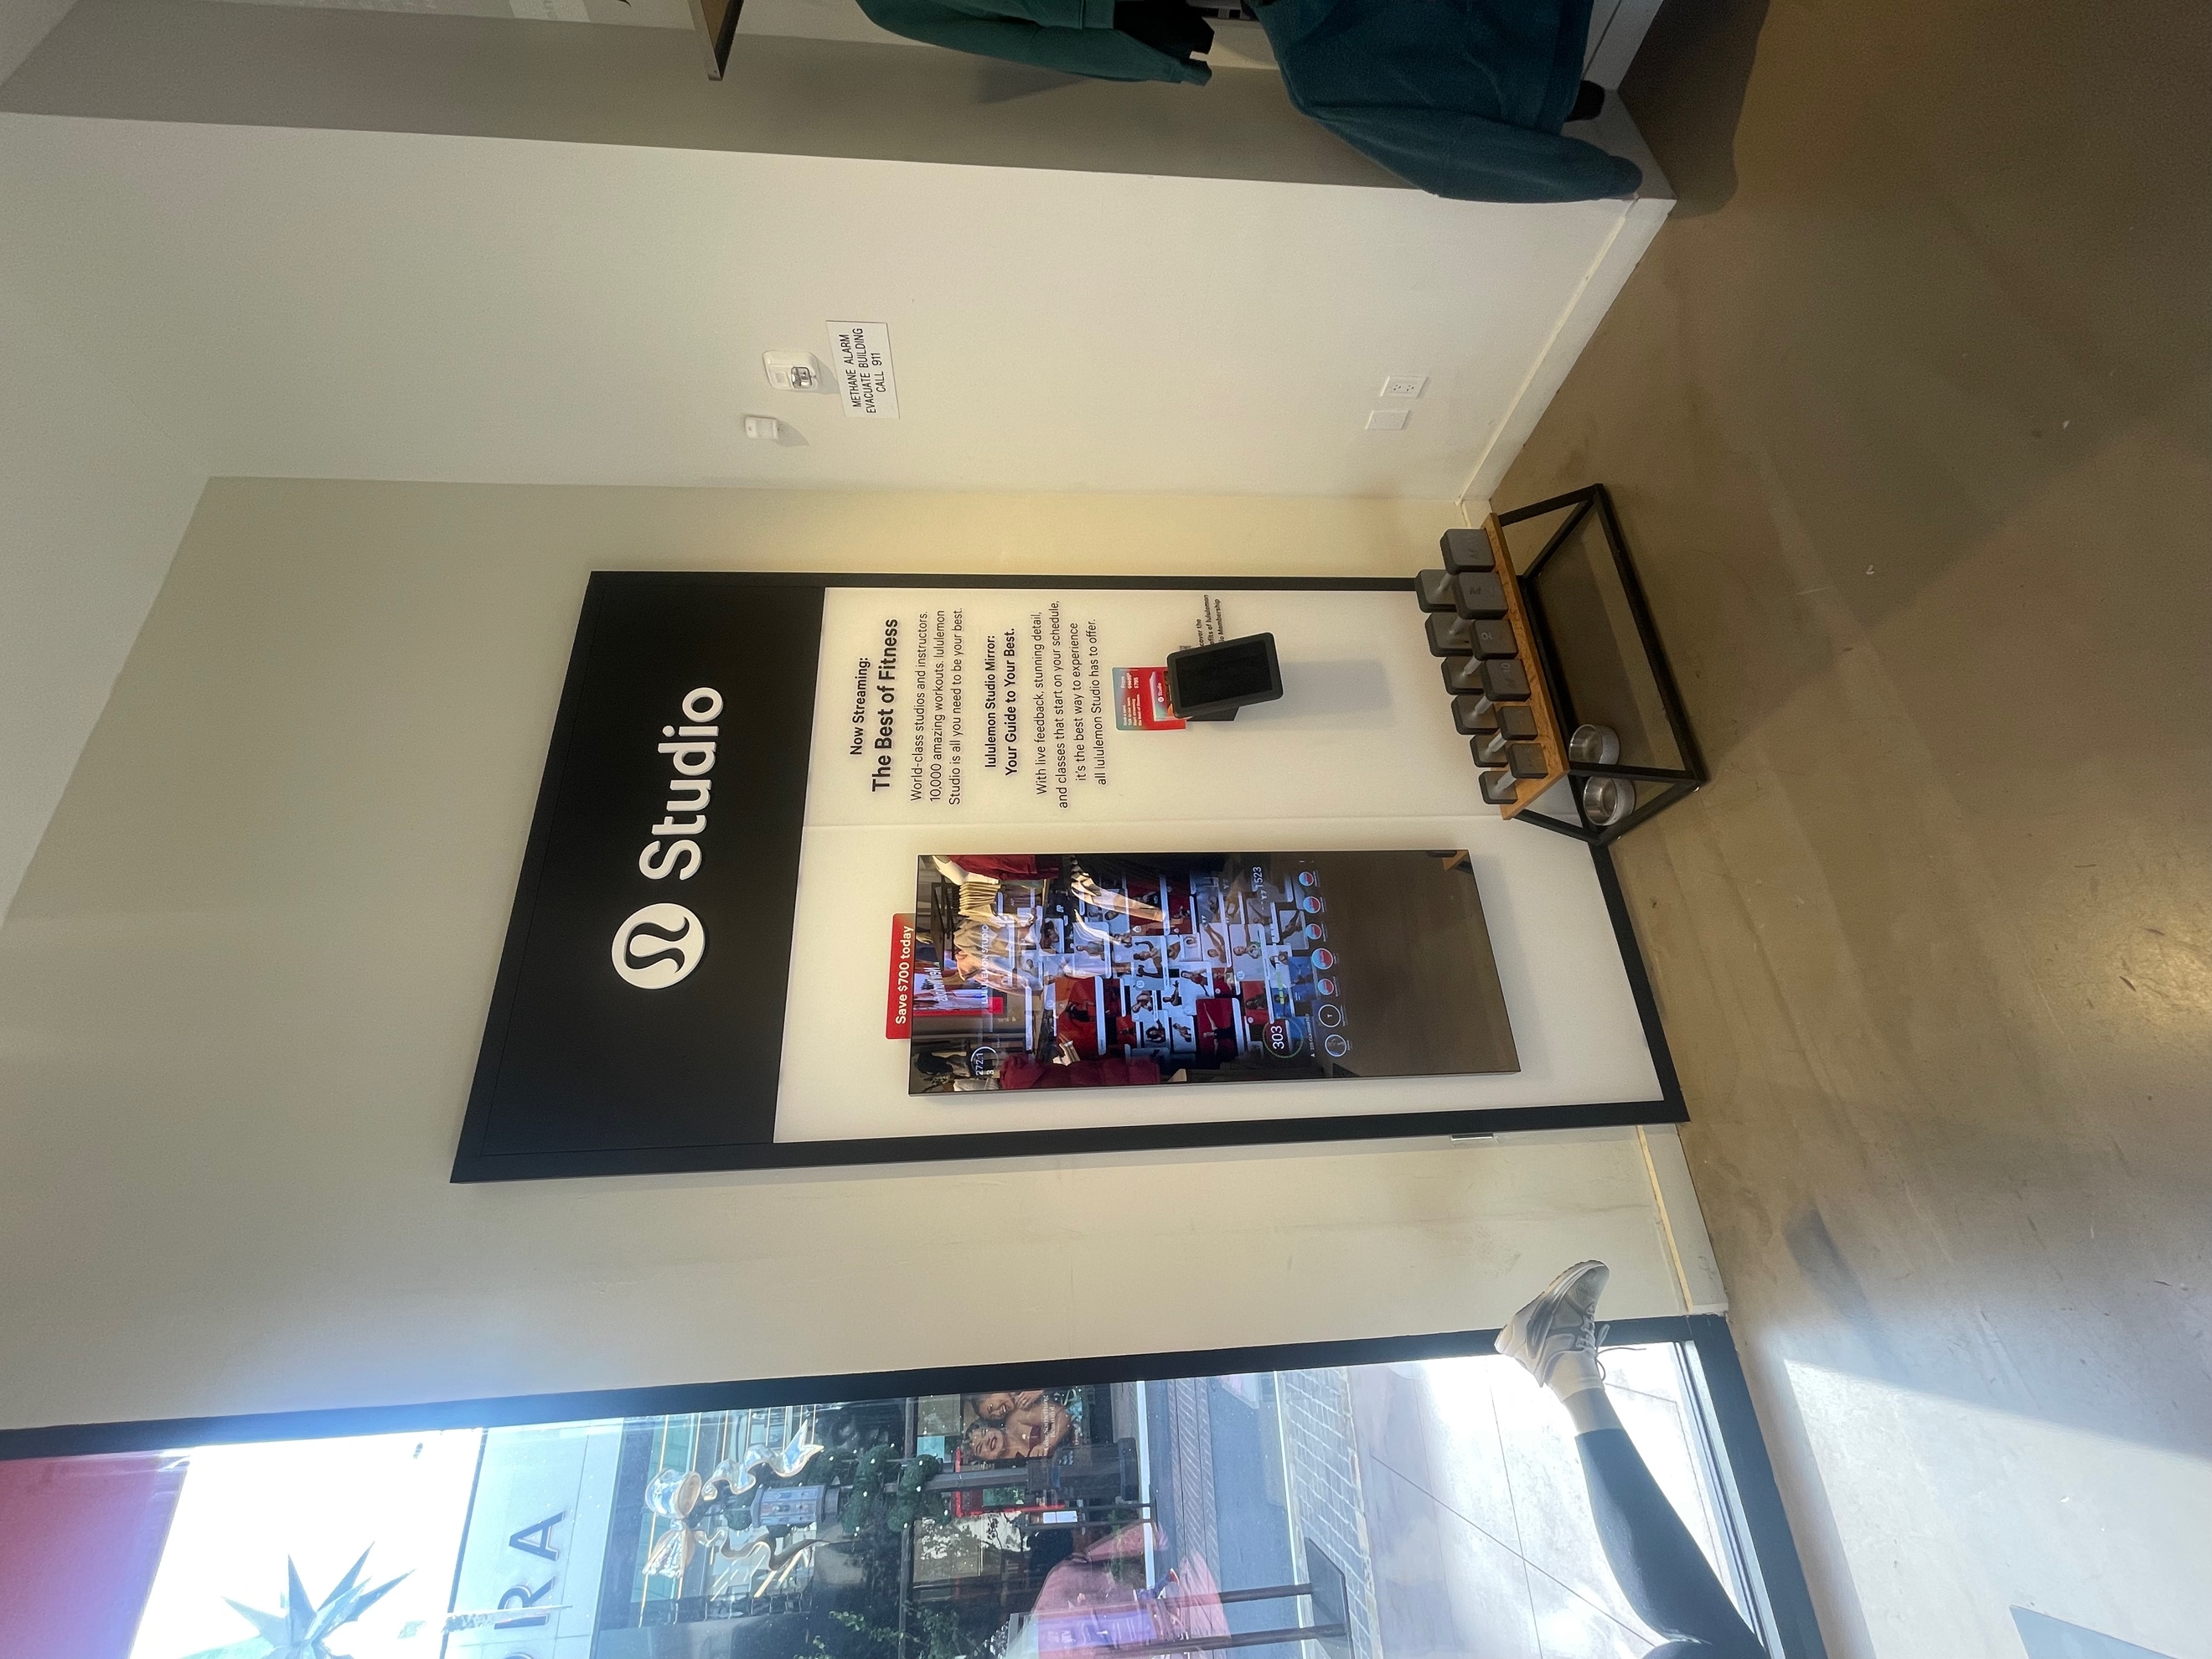



The other option Lululemon has is being a part of the sweat collective program. This program is a way for a diverse group of people to become connected by a dedication to an active lifestyle and community leadership- and of course their love for Lululemon (WS #1). Being a part of the sweat collective, it once again allows the customer to be a part of their community and feel like they are a family. Customers who are a part of the sweat collective get 25 percent and more off of products, they also get special invites on their latest product innovations and they help shape gear for the future by taking their feedback on products in order to make the gear better (WS #1). They make it really easy for customers to be a part of this because they offer it to group fitness instructors/ personal trainers, self-employed personal trainers, studio/ gym owners, athletes, coaches and team staff (WS #1). Lululemon has made this sweat collective to shown their passion for fitness activity and want to reward people who are involved in the fitness community. It provides the customer with a sign of passion and really brings out who they are and what they want a company to see in them (PI #9). Lululemon does a good job of putting together memberships and programs for existing customers to come back and stay engaged with their store.

Non-Digital Promotion Strengths:

- Daily fitness programs
- Variety of memberships
- Ambassadors from “Sweat Collective”
- “MIRROR” fitness product/ subscriptions

Non-Digital Promotion Weaknesses:

- Customers not interested in programs
- Customers not joining their membership
- Cost of “MIRROR” is high

B7. Digital Promotion Objective(s), Analysis and Strategies Discussion

Digital Promotion Objectives:

Lululemon has an effective strategy for using digital promotions to find ways to get in contact with their customers, create brand awareness and gain long-term fans for their passion of fitness and community.

Digital Promotion Analysis and Strategies:

A. New/ Acquisition Strategies:

Lululemon has a very easy to use website that isn’t overwhelming for the customers and is a good start for customers to see their promotions. The biggest way that Lululemon uses digital promotions is through social media platforms. Their biggest platform that they use is Instagram with 4.3 million followers. This is a very beneficial tactic because one post of their product can reach over 4.3 million people. It is also beneficial for them to use a social media platform such as Instagram because they can get instant feedback from their customers, by them leaving comments or concerns about either the company or product on their posts. Lululemon has an average engagement rate of 0.30% with the average of the industry being 2.56% (WS #19). By having even, a 0.30% engagement rate it is showing that people are clicking on the products given and are showing interest and also shows what they are doing is working. It might not be a super high number as of right now, but it is showing growth. Lululemon also has a hashtag “thesweatlife” and it currently has 1.4 million posts from other people using it (WS #19). This is a good way for long-term customers to post about their product and get new customers to see the hashtag and find out what Lululemon is and what they are all about. Lululemon also uses other platforms such as Twitter, Facebook, and TikTok. There is always room for growth in social media platforms and Lululemon is staying on top of that.

Another way that Lululemon uses digital promotion is through their website and app. On their website they have many opportunities for customers to get involved and join memberships and programs. One process that they use that is beneficial for digital promotion is a section called “Be the first to know” (WS #1, 19). This is a valuable option for customers because with today’s society everyone wants to be first to new products. When signing up for this promotion it allows customers to get emails first before it is released to all customers. This newsletter signup page is also a spot where customers can see how the company prides itself on community and education (WS #19). This gives customers once again another chance to feel a part of the company and feel rewarded for shopping with them.

- Existing Customer Strategies:

Lululemon uses digital promotion in order to engage their customers into their new products in order to get existing customers back into the store. The main thing that Lululemon does for their existing customers is having them follow their social media platforms because it is the easiest way to get instant messages about new promotions and products. By having customers follow social media platforms and stay involved with Lululemon it also helps them stay involved with the community. Lululemon has programs and memberships for existing customers to get involved in and learn more about the company. They also have a newsletter that you can sign up for where existing customers can see what new products are being made and when they will be released so they are the first to know. This strategy is a good source for Lululemon because they know that customers nowadays are always wanting to be first to know everything so having a service like this is very beneficial for existing customers to feel a part of the company and stay involved.

Digital Promotion Strengths:

- Keeps customers updated
- Social media platforms reaching millions of customers
- Website and apps showcasing products
- Newsletters/ memberships/ programs
- Convenient shopping

Digital Promotion Weaknesses:

- Customers annoyed by constant emails
- Not able to try on products online
- Hard to get ahold of online

Competitor #2: Vuori
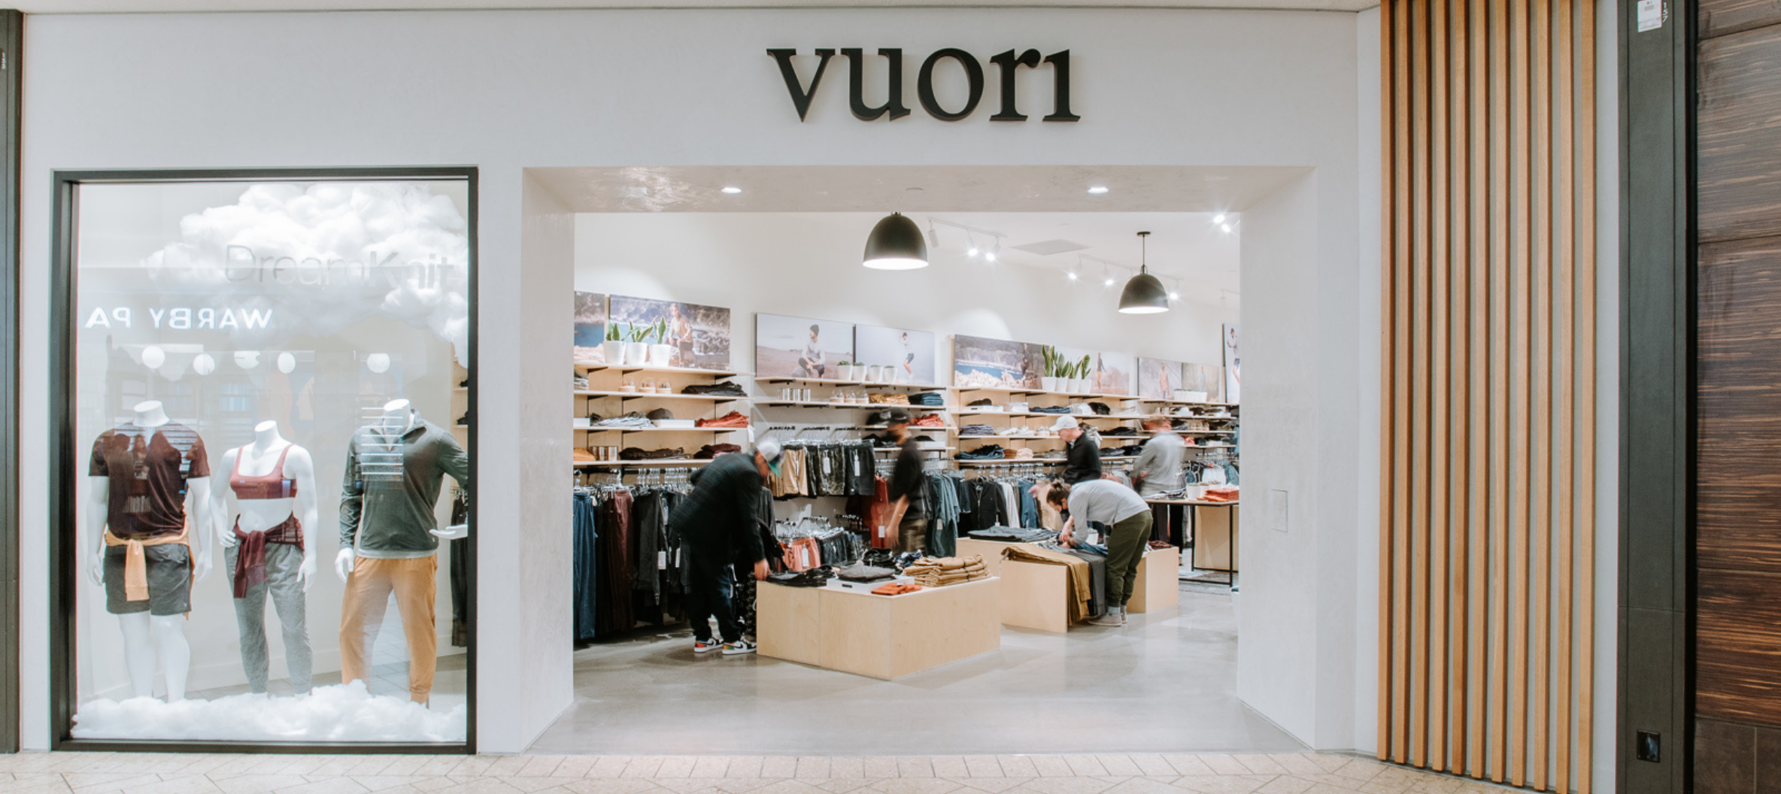

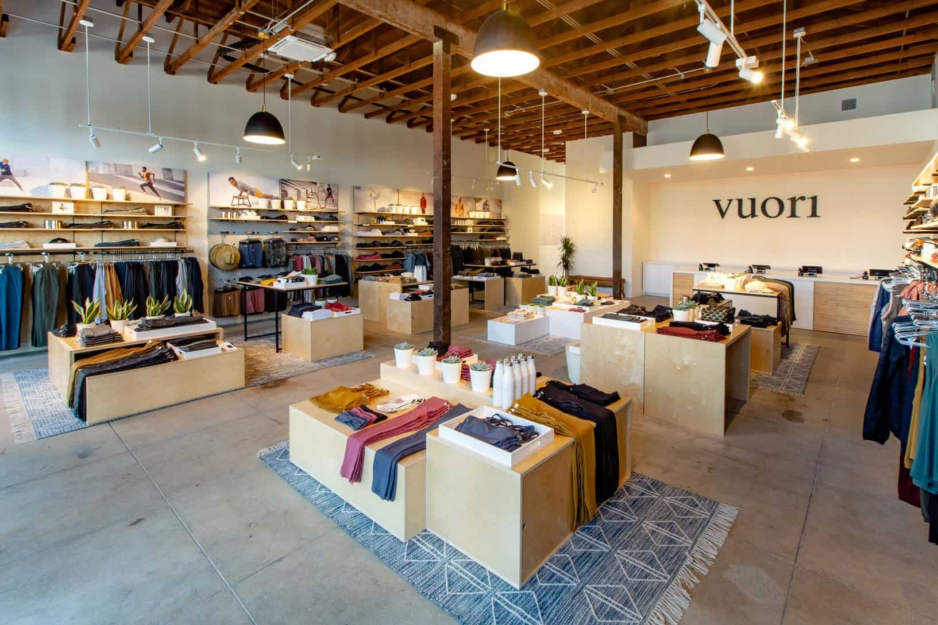

B1: Positioning Maps

Why? After doing customer interviews and my own research on each of these companies I decided to place competitor #2, Vuori, in the upper right-hand corner because of their extremely comfortable products, that come with a luxury price (CI #4, 10, 11, 14, 15). I believe that Vuori is in a good place right now because they make such good quality products that it makes sense that their clothing can be pretty expensive. I feel that they could make their prices a little lower, but with Lululemon as one of their main competitors it will be hard for them to do that. When you put on a piece of Vuori clothing you can instantly feel the comfort and see the hard work they put into making each piece of clothing.
Vuori
Gymshark

Alo
Lululemon
Extremely
Comfortable
Less
Comfortable
Average Prices
Luxury Prices
Little/No Vibe in Store
Lululemon
Why? I placed my competitor #2 Vuori in the lower left-hand corner. The reason I have placed them in this location is because of their known California vibe in the store (CI # 4, 8, 9, 10). Vuori has done a significant job of having customers walk in and immediately see how they show their passion for the beauty of California. This is really beneficial because it gives customers something to associate with and make them feel welcomed. The other reason they were placed in the lower left-hand corner is because of their semi-knowledge of products. After interviews I feel that I have seen some knowledge, but nothing that has blown me away like my competitor #1, Lululemon has shown (CI #5). Vuori shows to have a good vibe in their store, which will continue to attract customers, but a little more product knowledge from employees would help customers as well. It is still a new company so there is still more for them to learn.
Vibe in Store
Gymshark
Alo
Vuori

Employee Knowledge on Products
Rare Knowledge of Products

B2. Primary Target Market Analysis

Primary Psychographic:

Psychographic would be ranked at the top for Vuori because of how they market towards customers who are interested in fitness, and a surfer/ California vibe.

Why?

Vuori as a company has a very strong sense of their customers and do a good job of finding a way to attract them into coming into their store. Walking into Vuori you can notice the way that they bring out a California vibe to make customers feel welcomed for who they are (CI #8, 9). With a California vibe, it always seems to come off as being a generic surf shop, but what has made Vuori so unique is the way that they have brought in yoga clothing into a surfer look. It is fascinating that an owner who had the passion for yoga, and moving to California and falling in love with its beauty, was able to create a product for both passions (PI #7). Vuori is a company who wants to make customers feel at home and while showing how passionate they are of where they started their company. Overall, they want to make the customers feel like they are able to do yoga, while fitting the California stereotype.
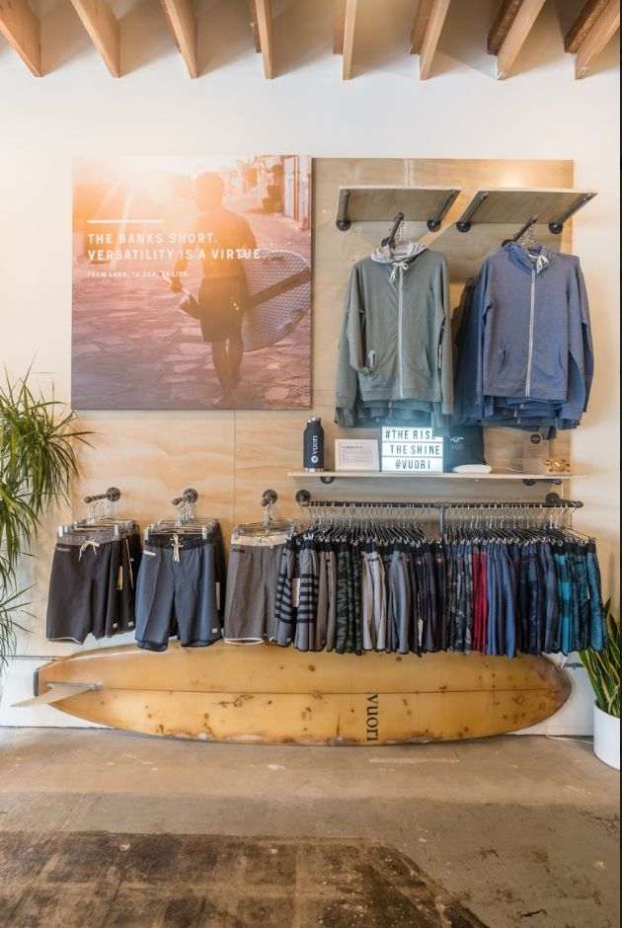



Primary Demographic:

Vuori is a new company, but has put a name out for themselves the past couple of years (Art #8; PI #4). Many customers are starting to get invested into Vuori so the likeliness of someone stopping at their store in the mall is very likely. Vuori is focused on the 18-35 age range. I would say they are focused on a middle-class income, but close to being on the upper class. They definitely want to look for customers who are interested in working out and want to look the part of California.

Why?

Vuori had a strong process of finding a certain way to finding the perfect target market for their company. Rather than Vuori being set on selling fitness clothing to everyone in the industry, they found a way to break down their product so it can fit certain customer needs. The way they did this is putting yoga, and the California look into one (CI #9). They also set the price for how unique and the overall quality of the product is, knowing that the customers would understand why it is set for how it is (PI #7; CI #11). With the prices being a little high customer will be able to buy a product knowing that it will last them a long time instead of buying something cheap and having it last only a couple months.

Primary Benefits:

The benefits of buying from Vuori is knowing that the product you are purchasing is going to be a great material and last you a long period of time. Their products also give you the California vibe, which can make customers showcase who they are with what they wear.

Why?

When looking at products at Vuori you can instantly notice how well they make these products. When looking at them you can see the hard work that they put into the designs. When feeling the products, you can feel how durable they are and the quality materials that they use (CI #4, 10, 11). Going into a Vuori a customer is going to feel right, they base their company off of California (CI #4, 8, 9,10). If you are into surfing or any outdoor activity it is the right place for a customer to come. Even if a customer is coming in to just look around it is a perfect place for them to feel welcomed.

Primary Geographic:

Vuori is more of an upcoming brand so in the demographic it really has been incorporated yet this is why I ranked it last. The name of this company is on the rise, but where it is starting is where they will do their best. They are based out of California because that is what they want to be known for so I feel it will best fit them. Most of these stores are found inside of a mall, or in a popular location. It is placed where there will be a heavy flow of customers.

Why?

Vuori already has a well-known plan for their company. This plan consisted of making California clothing as fitness wear. Obviously since Vuori has made their clothing based off of California they are going to want to keep their brand in that state specifically because that is where it will most likely do its best. By placing this company in California malls as well it makes them standout because you rarely see a company with a unique twist like this and it will be in a lane of heavy customer traffic (CI #10). This also makes it very convenient for customers so they don’t have to drive to one individual store they can do shopping elsewhere as well.

B3. Customer Experience Analysis and Strategies

Customer Experience Objective:

The primary goal of Vuori in order to give the best customer experience possible is by setting a California vibe, hiring employees who want to be there, employees that are knowledgeable, and that offer comfy clothing for fitness (PI # 2, 4, 7; CI #4, 8, 9, 10).

Customer Experience Analysis and Strategies:

Vuori does a phenomenal job of bringing good customer experience to consumers. Vuori has found a way to bring California as a whole state into a fitness clothing brand (PI #7). Vuori has taken what customers think of California and made a unique twist to their product. Instead of making the same generic athletic apparel they made it specifically to fit the customers of California (CI #8, 9 ,10). With the California setting, this comes with unique decorations such as surf gear and photos of athletes in Vuori gear close to the beach (CI #12). Another example of how Vuori provides good customer experience is through their employees. In order for this to happen employees need to be very knowledgeable. Employees at Vuori are aware of all the different fitness activities taking place so their customers can get the exact style of clothing for whatever fitness activity they are planning to do (PI #7; CI #9, 12, 15). Vuori is in the right direction for providing great customer experience, they set a good vibe and make sure employees are happy to be there and are knowledgeable about the products at the store.

Unlike Competitor #1 Vuori has more of a unique style for their fitness clothing. Vuori shows passion when making their products by putting their love of California into their products. Making clothing to fit customers that love the beach, surfing and all outdoor activities it gives their product an edge (CI #8, 9, 10). Vuori made it so their product can reach almost all ages depending on the activity that they are looking to do. This provides any form of customer no matter age to come in and get something that will be a perfect fit for them (CI #4). This provides customers to come in and be excited to buy a product that will fit their personality.

Vuori has also done a successful job of showing love for the community. Vuori has shown ways to be an impact on our environment. They have shown that they are making products to never damage our environment. Vuori has made meaningful progress in securing a low-climate future (WS #2). Vuori is Climate Neutral Certified which means that they measure and offset all of their carbon emissions from making and delivering products in each year (WS #2). They have partnered with Pachama & 3Degrees to offset their 2021 footprint, they supported the Chestnut Mountain Improved Forest Management Project (Forestry) and the Dempsey Ridge Wind (Renewable Energy) (WS #2). Vuori shows love for the environment and it helps customers know that the products they are purchasing are being made and recycled for the better (CI #4, 16). Vuori continues to look to the future and finding new ways to better their products to help the environment and provide customers with products that are known to be environment friendly.

Customer Experience Strengths:

- California vibe and unique store design (CI #8, 9, 10, 12)
- Joyful and knowledgeable employees (CI #9, 12, 15)
- Environmentally friendly products (CI #4, 16)
- Comfortable products (CI #4, 10, 14, 15)

Customer Experience Weakness:

- Prices can be expensive (PI #1; CI #11, 18)

B4. Price Objectives, Analysis & Strategies Discussion:

 | Lululemon | Vuori | Industry Average
Athletic Shorts | $58.00-$88.00 | $68.00-$78.00 | $48.00-$88.00
Athletic Shirts | $58.00-$78.00 | $54.00-$74.00 | $58.00-$88.00

Price Objectives:

Vuori has priced their products around the fitness clothing average. The fitness clothing industry is more on the high end of meeting competition because of the high-end costs. Unlike competitor #1, Lululemon, who has set the tone mainly for this industry, they had to price around them in order to stay in competition. Vuori has shown to make really unique products with great quality so they have been able to get away with higher end prices even for being a new company. Vuori’s main focus is to target customers who have a passion for California that are from the upper class (CI # 8, 9, 10, 11, 12, 14, 15, 18).

Pricing Analysis and Strategies:

Vuori and Lululemon both have similar pricing strategies. Both are high end companies in the fitness clothing industry. Vuori has made themselves a high-end company because of the quality of their materials (CI #4, 10, 14, 15). Instead of Vuori setting prices at a lower end they were able to target the upper class. It is easier for them to do this because companies have already set a tone for prices in this industry so they were easily able to set a price around the same of their competitors. Since their quality comes with so much comfort they are able to set a price at a higher-end knowing that their customers are going to be happy with their purchase. Vuori has also made a unique twist on their product that makes them able to put out a higher price knowing that customers can come in and get something that fits their personality instead of generic fitness apparel.

I feel that Vuori has done a great job of their pricing strategies by researching their competition and figuring out how they can get in the game. Their prices are relatively the same as Lululemon, they do have some prices that are lower, but it is very slim. I feel that in the fitness clothing industry it is very hard to be selling products at a low-price unless it is cheap quality. In fitness any athlete is going to want a product that is comfortable for their activity. I feel this is very important for the fitness clothing industry. For instance, if Vuori lowered their products cost by 25% it would put them out of the competition from their competitors. The reason for this is if Vuori lowered their prices then they wouldn’t be able to make much money and would barely be breaking even, with the quality of products they use. It also isn’t beneficial for Vuori to raise their prices by 25% because they are a new company and haven’t built a big enough fan base to keep customers coming in. With being a new company, customers will come in and see the rise in prices and will most likely take their business to a company who is putting out similar quality in products with a cheaper price. I feel at the end of the day Vuori made the correct decision on their pricing strategy.

Price Strengths:
- Customers hold high value on product quality (CI #4, 10, 14, 15).
- Comfort of products benefit fitness activity (CI #4, 10, 14, 15).
- Clothing can be used as casual wear and fitness (CI #8, 9, 10)

Price Weaknesses:
- Only targets middle to upper class (CI #8, 9, 10, 11, 12, 14, 15, 18)
- Rare promotions (PI #1)

B5. Place Objectives, Analysis, & Strategies Discussion
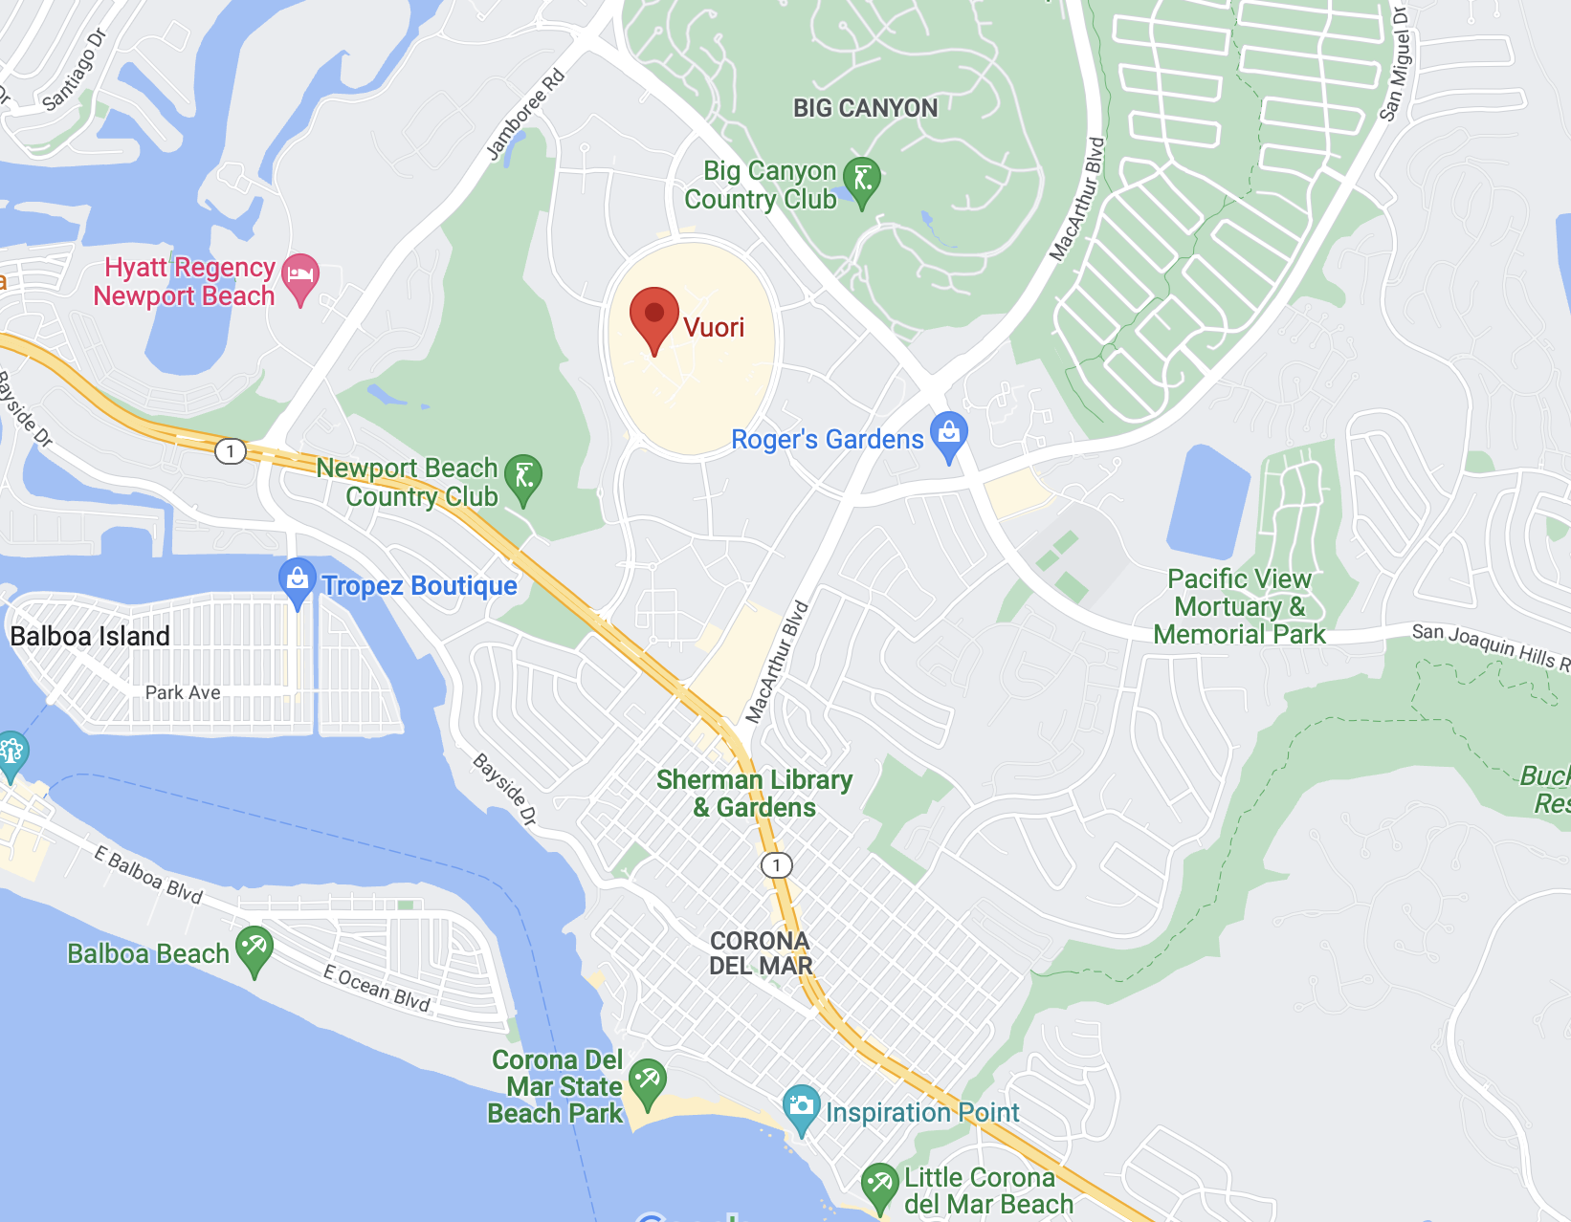
Place Objectives:

Vuori has worked hard on finding perfect locations for their company. One of my favorite locations and one of the main ones I have gone to for this project is the Vuori located at Fashion Island in Newport Beach, California. This mall is known for its heavy foot traffic so it is a perfect spot to be located. Being a company who basis its products off of California it is a perfect opportunity to locate themselves where they know their product will be looked at often.

Place Analysis and Strategies:

Newport Beach, California is one of Vuori’s best locations because of the population and foot traffic that Fashion Island brings. Vuori is a California based brand so it only makes sense that they are located in California and especially a beach. Newport Beach, California has a population of 85,249 people and this isn’t including tourist that come and visit the area (WS #15). Being a high populated area, it gives Vuori an edge knowing that they will have plenty of attraction being located in this area. Fashion Island shopping center is a very well-known mall in Newport Beach as well. Fashion Island attracts nearly 16 million visitors a year since 2017 and is still climbing (WS #16). With that many customers coming into Fashion Island Vuori has a great opportunity to get new customers on a consistent basis and keep long-term customers that are from the area.

The Vuori that is located in Fashion Island is roughly 10 minutes from the beach. This is a great location for them since they are a California based brand (CI #8, 9, 10, 12). Selling products that are uniquely made for a California vibe it will have customers wanting to wear their products to the beach. They located this company perfectly so they can go get new beach attire and wear their new clothing right to the beach after shopping. It is also a great opportunity for new customers coming in who want to go to the beach, but don’t own any clothing for it.
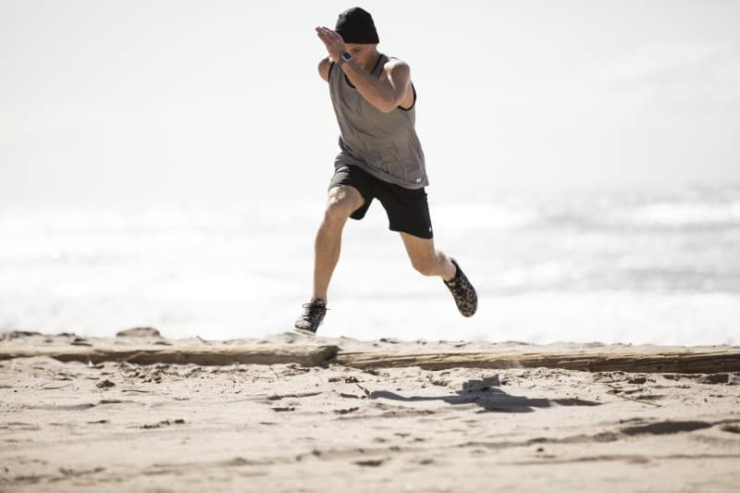


Vuori has expanded some of their products specifically for surfing or just any water activity in general. They made board shorts for surfers because it is their way of life. They wanted to design a four-way stretch premium fabric for reduced chafing and maximum mobility and mesh-pockets for reduced water drag (WS #2). Vuori has specifically done this to target people that have a passion for surfing and beach activity. It was smart of Vuori to make a product like this because of how close they are located from the beach. This is a perfect opportunity to give quality products to customers that are located in the area and want to enjoy beach activities.

Place Strengths:

- High populated area (WS #15, 16)
- Located for their target audience (WS #2; CI # 8, 9, 10, 12)
- Able to attract tourists (WS #16)

Place Weaknesses:

- Competitive location other companies in the shopping center (WS #1, 16)

B6. Non-Digital Promotion Objective(s), Analysis and Strategies Discussion

Non-Digital Promotion Objectives:

Vuori’s main objective of non-digital promotion is to increase their brand awareness and gain long-term customers who have a passion for fitness.

Non-Digital Promotion Analysis and Strategies:
- New/Acquisition Strategies:

Vuori has done a good job of non-digital promotion by the use of their logo. Vuori’s logo pops because of its unique 3D design which attracts the eye of the customer. Another special piece to their logo is the sunset design they have on it. Since California is known for a sunset by the beach they incorporated that well into their design and will attract the customers eye once again. This can provide a simple design that is easy for a customer to understand what they are all about as a company.
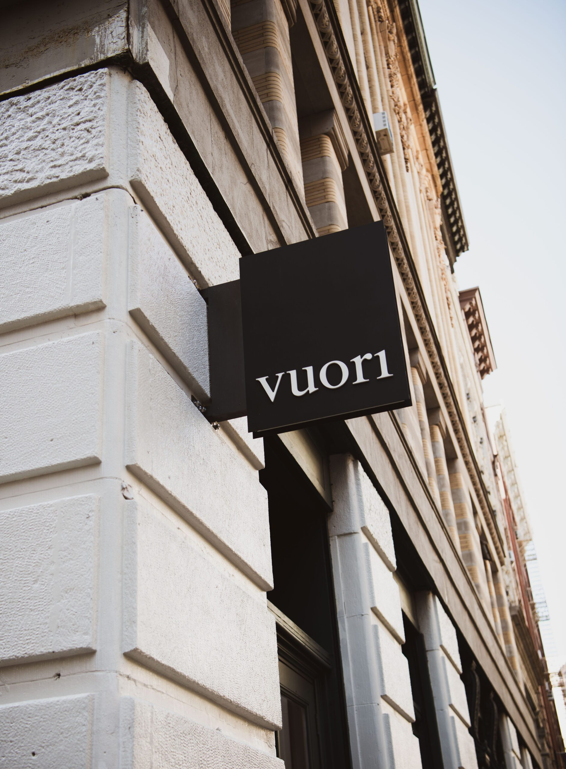


Vuori has also done a good job of promoting their brand by using influencers to promote their product by just wearing their clothes. Vuori has reached out to influencers that are known for fitness activity to showcase what their brand is all about. A known surfer who is an influencer for Vuori is Pat Millin. Pat Millin does a great job of wearing Vuori’s clothing at big events and around the beach to showcase their product. Another Vuori influencer with a big name is Olivia Dunne. Olivia Dunne is a gymnast who is well known in the TikTok community and gymnast community. She does a good job of wearing Vuori during training activities when there is an audience to see the clothing. Vuori is doing a good job of promoting their products by getting well known influencers who are going to wear their products for what they stand for.

- Existing Customer Strategies

Vuori interacts with their customers by having a program called the ACTV CLUB. Something that Vuori does is have a place where people of all abilities can come together for a little sweat therapy, to encourage each other and get a little bit stronger everyday mentally, physically and spiritually (WS #2). This program is really nice for customers to be involved in Vuori and for Vuori it makes customers fit in and gain long-term fans. Vuori teams up with some of the best trainers to bring a variety of free, quality classes ranging from strength training, yoga and everything in between (WS #2). This is really nice for customers because there is a variety for all activities, which opens it up for more customers. Vuori has a schedule so customers can stay on track and do whatever physical activity they are looking for. This may be used mainly for existing customers, but it is a good way to reach new customers as well so they can get in the game as well.

Non-Digital Promotion Strengths:

- Logo/ brand showcases what they are all about
- Influencers
- Daily fitness programs

Non-Digital Promotion Weaknesses:

- Very few non-digital promotions (limited)
- Customers might not be interested in their programs
- Few influencers (newer company)

B7. Digital Promotion Objective(s), Analysis and Strategies Discussion

Digital Promotion Objectives:

Vuori does a good job of using digital promotions to find ways to get in contact with their customers, create brand awareness and gain long-term fans for their passion of fitness and California.

Digital Promotion Analysis and Strategies:
- New/ Acquisition Strategies:

Vuori’s website is very easy to use and gives customers many opportunities to get involved with their company. They have ambassador programs where you can get 40% off all apparel. This is very unique for them because you can apply for any type of fitness activity you are involved in. I am actually apart of this program because I am an NCAA athlete. It is a good way for them to reach out to new customers and I actually found this out from researching this company. They make it very accessible for any customer to get on their website and apply for this. Having these programs for people is really beneficial because the product is already known for its expensive products so for my case it helps since I am a college student and can still wear products that fit my needs. Their website also has many different parts to it so it isn’t just buying products it shows who they are and what they are all about, which is really impressive to a new customer on the website.

Vuori has also used social media platforms to reach out to new/ existing customers in order to keep up with digital promotions. Vuori uses social media platforms such as Instagram and TikTok as some of the biggest. On Instagram Vuori has 515,000 followers, TikTok they have roughly 135,900 followers. Since Vuori uses these platforms as digital promotion they are easily obtaining an audience. With the growth of Instagram and TikTok they are able to post pictures of products and videos of them as well to engage customers. Vuori has also teamed up with Olivia Dunne who has 6,300,000 followers on TikTok. This was so big for them because she is showcasing their products in her TikTok videos. This has helped Vuori reach their target audience from a variety of ways.

- Existing Customer Strategies:

Vuori uses digital promotion in order to engage their target audience and create brand awareness. By being a part of Vuori’s community they have you sign up for an email like most companies do in the fitness clothing industry. This is a good way to reach your target audience because you can send emails to customers that are subscribed and keep them up to date of clothing changes and prices. This provides customers with special promotions in order to keep them coming to stores. They also provide fitness classes for customers that are involved for them to keep coming back and workout and show off their unique clothing from Vuori.

Digital Promotion Strengths:

- Keep customers updated
- Building a community from programs offered
- Influencers
- Showcase products
- Convenient shopping

Digital Promotion Weaknesses:

- Customer annoyed by constant emails
- Influencers they don’t like
- Can’t try on products online
- Hard to contact online

Section C: Timeout



C1. Ethical Issues & Action Plan

- Hypothetical Issue:

As an up and coming Christian business owner I need to make sure that my business is running smoothly and keeping up with any ethical dilemmas that may occur. I understand that in my personal position that I am a new business owner with a family to feed and bills to pay so I am having to deal with whatever obstacle comes my way. Also, as a Christian business owner I need to not neglect my faith, but put my faith into my work.

My new company had started to grow at a rapid pace and started being known in the fitness clothing community. One morning I was opening up my store and I noticed Dominique Jones also known as Lil Baby walk in. I was beyond shocked because I didn’t realize my store was already reaching notice of celebrities. My store has been doing well, but we haven’t been able to gain much revenue since we are still a new business. We have been waiting to catch a break, but nothing has come through for us yet.

I noticed Lil Baby walking around our store and feeling our products material and trying some clothing on as if he was looking to make a purchase. He finished trying on our products and was very impressed by the materials. I was so excited just knowing a celebrity came in to view our products, but to like it made it even better. He ended up approaching me when he was about to leave and told me about this huge basketball tournament that happens every year for rappers. This is called the Crew League that is showcased on a YouTube channel called “Revolt.” After telling me about the basketball tournament he came out and said “I want your company to use your materials to make our uniforms and I will keep your logo as an advertisement on the jersey and pay $100,000 if they can be done in 2 weeks.” I couldn’t believe with what I was hearing because I knew this is what our company needed. This could get our company to the point where we are about to break-even and gain revenue.

After I started to get back to reality I started to think about what kind of celebrity Lil Baby is. Lil Baby is a famous rapper and has a reputation of using drugs and having women all around him. This started to make me think of the decision that I have to make and face who I am and what this company represents. My company is working on targeting a college audience who is in the prime years of getting into bad habits such as Lil Baby is doing. It might affect my business because it strays away from what we represent. College students are well aware of who Lil Baby is and if they know he is wearing the clothes from my company they will easily want to come in and get the same product. This makes my decision very tough because if I went with the deal I would be able to get the head start that I need and I will also be able to get a huge number of new fans into my store.

- My Tension:

If I ended up taking this deal it will end up reaching a huge audience of people and get my name out there. With Lil Baby and his team wearing a jersey made from my companies’ material and our logo on it, it will be played on “Revolts” YouTube channel that has roughly 2.23 million subscribers. Revolt averages over 1 million views on their “Crew League” episodes so I know that it will be shown to many people. Lil Baby also has 20.9 million followers on Instagram, which will be a huge for our company. This would help my company takeoff and get national recognition. However, Lil Baby is a rapper who is known for making music based off drugs, money, and women. By having him promote our company it doesn’t match what we are all about. My company has high values and should be represented in the best way possible. This is a hard decision for myself to make knowing that we need a boost right now to get our company in with our competitors, and also a hard decision knowing that I could lose my company and put employees at risk as well.

- Biblical Principles

- Christians should be decisive and make great decisions
- Joshua 24:15 – “But if serving the Lord seems undesirable to you, then choose for yourselves this day whom you will serve, whether the gods your ancestors served beyond the Euphrates, or the gods of the Amorites, in whose land you are living. But as for me and my household, we will serve the Lord.”
- Proverbs 3:5-6 – “Trust in the Lord with all of your heart and lean not on your own understanding; in all your ways submit to him, and he will make your paths straight.”

- Christians should be more aware of what is right and wrong.
- John 3:19-21 – “And this is the judgement: the light has come into the world, and people loved the darkness rather than the light because their works were evil. For everyone who does wicked things hates the light and does not come to the light, lest his works should be exposed. But whoever does what is true comes to the light, so that it may be clearly seen that his works have been carried out in God.”
- James 4:17- “So whoever knows the right thing to do and fails to do it, for him it is sin.”

- Action Plan

While sitting and thinking on this ethical dilemma I have decided that I can’t take this offer from Lil Baby. I came back with a counter-offer of a third of his price. I asked if we could still make the jerseys for him, but we asked if he could make a logo for it and not have our company representing it. Lil Baby was thrilled to still have our materials be used for his athletic wear for this tournament.

- Rationale

As a company with high standards we wanted to make sure we weren’t representing the wrong community and we wanted to be known for different reasons. We may have lost a big opportunity to advertise our company at the tournament, but I felt we were in a good position and there was no reason to rush our progress. I felt that Lil Baby and rappers in general have a stereotype of using drugs, using women, and using offensive language. I feel that my company stands out for its bravery, which our name is defined as. As a Christian I feel that we are held to higher standards especially when it comes to knowing what is right and what is wrong. Also, as a Christian we should be decisive and make great decisions even if it may hurt us in the short-term. I want my company to be strong and be held responsible for tough decision making. Therefore, we had to counter-offer Lil Baby to a third of the money and to use our material, but none of our logos. This gives a middle point for both our company and the customer. I felt this was the right answer for my company.
C2. S.W.O.T. Analysis

Strengths:

- Clothes will always be relevant (necessity)
- High quality material that is durable
- Comfort of products for all fitness activity
- I know how to price products to stay in competition or surpass it
- Knowledge has grown from doing customer and professional interviews
- Found competitor strength and weaknesses
- Location of company matters for target audience
- Digital promotion is essential
- Technology can improve/ change products rapidly
- Website and apps easy to navigate

Weaknesses:

- High Prices
- Don’t have a fan base since my company is new
- I have never created a business before
- Most customers already have a favorite brand
- Customers have trust in other companies
- No brand awareness
- Young employees aren’t at retail jobs long (frequent hiring)
- Long wait times
- Availability of all products

Opportunities:

- Southern California has a high population and big attraction for tourists
- Fitness industry is growing rapidly
- Technology with social media
- Product availability
- Employee knowledge with specific sizes
- Custom products

Threats:

- Fitness industry is already competitive with well-known brands
- Have to be adjustable as a Christian business
- Trends change often with clothing
- Competitors with a fan base
- Competitors with brand awareness already
- Large number of fitness clothing companies

C.3 Competitive Advantages

Problem #1:

Customers in the fitness clothing industry have encountered many problems when it comes to returning a product to my competitors (WS# 3; CI #20, 21, 22).

Solutions:

At my clothing store I want to find a way to solve the problem of returned items. No matter what store you walk into, whenever you have an exchange I feel customers always have troubles with returns. In my company, I will make a broad return policy so customers don’t have to be confused on what they can and can’t return. I feel when customers buy a discounted item they will be able to return it for the same price as it was discounted. If it is a normal product they will get the option to return it for full price or exchange it for another item. What will make my company unique is we will have one specific designed area to return an item with our policies listed so the customer has no confusion. I feel with this extra space it will cause customers to get in and out easier as well, since returns can always take longer and it will save them from waiting in line as well.

Problem #2:

After reviewing some interviews, I have concluded that the overall appearance of the store matters heavily (PI #7; CI #8, 9, 12, 21).

Solutions:

At my clothing store I want to be able to have customers come in and the store be very appealing to them and very organized. I feel having a store that is organized makes the customers shopping experience a lot easier and not overwhelming. I have noticed in my interviews that customers really focus on this because when they come in looking for a product they don’t want to dig through a pile of clothes. Something that I plan to do is have some of my employees dedicated to just focus on organization for shifts. This can have them folding clothes that are thrown around and making sure all products are in the right area. Something else that I plan to do is make my store split into a men’s and women’s section. I feel that this make it easy for the customer to come in and know exactly where to go without confusion. I want to have all my new products in the front, and have existing products organized for the type of fitness activity they are looking for.

Problem #3:

After talking with customers for my interviews I have found customers that really appreciate when the wait-time is short when checking out. Wait-times can be the reason some people don’t purchase products (WS #17; CI # 21, 23, 24).

Solutions:

At my clothing store in want to make sure all my customers are able to get in and out of the line without the struggle of waiting tremendous amounts of time. Having short wait times, it will give my customers reasons to never second guess if they should buy a product based off the line-time. After noticing how most of the businesses in the fitness clothing industry have a few amounts of registers to check out in I want to add a couple more to break up the line. I also want to incorporate a self-checkout for customers with an employee there to take off the censors on the clothing so we can make sure they aren’t stealing. This will give customers their own way to check out and do it at their own pace. I also wanted to look into the new advanced checkout where you don’t even have to wait in line. You scan your card when coming in and you can scan the product and you will automatically be checked out. This would give my customers a convenient shopping experience and not make them second guess on buying a product based off of the wait time.

Problem #4:

Prices in this industry have known to be pretty high especially with the competitors I have been comparing. All of these fitness clothing brands have upped prices leaving some customers dissatisfied (PI #1; CI #1, 2, 11, 17, 18).

Solutions:

At my fitness clothing store, I have to consider the costs of what it takes to make my products. Since it is a fitness apparel company the cost of my products is going to be more than a regular clothing store. Since fitness apparel companies have to make better quality for customers to be comfortable for workouts it comes with an extra cost. I have come up with solutions that could benefit my customers for the expensive cost of products. I want to incorporate a fitness program within my company and with that is a membership. This membership allows you to go to my companies’ workouts that they provide and will offer you discounted products for attending the workouts. I also have thought of incorporating a part of the membership that if you attend so many workouts a month you will be able to select a free product from a variety of options given. I feel this will help customers get opportunities to get discounted products through our company knowing that we come with a high price because of the fitness clothing industry.

Problem #5:

After more customer interviews I have realized that there can be a problem with employees who are not motivated to work (WS #3, 4; CI #2, 6, 20, 21).

Solutions:

At my company I want my employees to have fun while working, but also have a professional attitude. I will incorporate specific training for my employees so they can understand specifically what my company stands for. I want my employees to feel that they can be friends with each other, but know when they are crossing the line. I will provide ways to show my employees what professionalism looks like especially since most will be younger and might have never learned what it looks like. I want my employees to be motivated for work and have something for them to look forward to. I feel that if I can do this for my employers they will never have a reason to dissatisfy the customers coming in. If my employees do not obey the training they went through and don’t show professionalism, I will make sure to talk with them and give them a warning of how they need to change and what to work on. If my employer doesn’t learn from these mistakes and is not willing to change I will unfortunately have to let them go. My company is going to be known for motivated employees.

C.4 Internal Marketing Strategies for 3rd Product

A. Systems of Quality & Consistency:

Concern #1:

Since my company is in the fitness clothing industry we will be known for our quality of products. A concern will be our consistency in quality for our clothes.

Solution #1:

Customers especially in this industry will come back to our store simply off the quality of our products. With how much effort we put into the quality of our products it will be a way for customers to build trust with us. Customers will be comfortable in our wear and feel their best when they are in any type of physical activity. If our quality of products becomes inconsistent it will leave customers questioning our company and not let us be able to build trust with them. In my company we will have technology that will be advanced in order to not have inconsistency in the quality of what we produce. I will need to be up to date with our technology and machines that we are using to make sure there aren’t any errors. If our technology and machines used to produce our clothing somehow make mistakes and we get shipments of them, I will put these products up for a discounted price and display what is wrong with them. This will give the customer an understanding, so that there is no reason for them to be questioning our quality. This will help our company build trust by not trying to get away with the little things.

Concern #2:

Another concern that can occur would be the inconsistency of customer service.

Solution #2:

Learning from my interview’s customer service goes a long way. Many times, customers go into a store and experience an inconsistency of help from employees. When this happens customers often feel that the knowledge of the employee is lacking. Going into a store as a customer you should feel welcomed and be able to talk to employees knowing that you can be helped efficiently and not have to guess. With the fitness clothing industry, I feel that almost anyone can work here and that is why my company needs to focus heavily on customer service and proper training. Every small interaction that takes place is beneficial because it builds a relationship with the customer. When I am hiring employees, I will make sure that they are well aware of what we expect when it comes to customer service. I will incorporate different strategies to help new employees get out of their comfort zone and start building relationships. I feel that when I incorporate these understandings to my employees it will help them lack confusion and be able to provide consistent customer service.

B. Employee Satisfaction and Training

Concern #1:

A possible concern could be employees that are simply working at my company just for the paycheck and not worried about anything else.

Solution #1:

I feel that when an employee is working for expanded reasons than just for a paycheck it shows how motivated they are and passionate. When customers are working just for a paycheck it will show in their customer service. These employees will not be going about their work in the best way and will end up leaving a negative impact on our company. At my company I am going to be very on top of who I hire in order to make sure there is employee satisfaction. During my interviews I will make sure to ask questions and find ways to see if the employee is here to represent my company or here just for the paycheck. I don’t want to rush my hiring process because it will lead me wondering how my employees are going to act. During my interview I am going to look for someone who is passionate about fitness and willing to go the extra mile to satisfy customers.

Concern #2:

Hiring under qualified employees can be a concern throughout my company because they won’t have a good understanding of my business and what we represent.

Solution #2:

When I am going through the hiring process of my company I am concerned that I will run into hiring employees who are not as qualified as I thought they were going to be. The concern I am dealing with is the thought of hiring an under qualified employee and them not being able to represent my company because they have never been prepared to do so. In my company I will make sure to look deeply into the applications sent in and make sure they meet the qualifications of our company before we even get into the interview phase. I want to hire employees who have some background in fitness because that is what my company is representing. A way that I can ensure employees are qualified for the job before they step foot on the floor I will provide specific training and a learning course. The learning course will consist of my company’s background and how we got to where we were today. I don’t want to keep any secrets from my employees and it will give them an opportunity to build trust with me. This will help the trainees grow their knowledge on the company and become qualified for the job.

C. Research Systems

Concern #1:

Customer Feedback is going to be a beneficial way for my company to learn from its mistakes and grow.

Solution #2:

In my company and any company in general, I feel that customer feedback is one of the best ways to get instant results of what you are doing right and what you may be doing wrong. As a business owner I need to be able to take my customers feedback and make sure I am applying the changes. The customers are the ones that run this company, because when they step foot in the store and when they step foot out of the store they have left with an impression on your company and that impression is either what brings them back or might leave them to never come back. So, for example, my company is going to have a specific spot on our website for customers to leave comments about either purchase, store organization, employees, and products etc. My company will also be on social media platforms so customers can leave comments on our posts, which will give us instant feedback as well. I feel customers have the right to express their opinion on my company because they are the ones who are making this possible. With customer feedback it will help myself and employees become adaptable to all of our customer’s needs.

Concern #2:

Another concern I have is my clothing being made out of the materials as promised to customers. There can be many errors and this can cause trust issues.

Solution #2:

In the fitness clothing industry my materials have to be better than a normal clothing stores product. The reason for this is because my customers will be putting their fitness to the test, while wearing my clothing. I have to make all my products out of materials that will best fit the customers fitness activity. I want my products to be environment friendly and doing so I want them to be recyclable and made out of materials that will not hurt the environment. A solution I have for this is teaming up with a foundation that will show my customers that my customer is being made from good materials. I will strictly show what are products are made from and how they can be recyclable because of how much customers care about that nowadays. With my recycled materials I want my customers to see a story behind each product made because it will show them how much my company cares and that each small product being sold has a story.

C.5 Creating Options

Option #1:

My first option for my company is being able to lower prices in order to create a fitness clothing store that can reach all audiences and not just the middle to high class. The main reason I want to do this is to allow myself to reach out to college students who may not have the budget to afford the more expensive clothing at my competitors. I feel this will be a huge benefit for me because my customers aren’t able to get quality clothing at a reasonable price. This will make my company standout because no one in the industry that I researched were having clothing that was affordable, especially for college students when it is the prime time for their fitness in life. Fitness as a college student is a huge thing and is usually where they begin and it is a great opportunity for these customers to start their fitness journey with my company.

Option #2:

The next option I have for my store is providing a weight room inside in order to bring customers into the store. Since my company is focusing on college students it would be a great way for them to come join our environment and start their fitness journey. A good way for us to do this is offer memberships to our customers so they can sign up and feel like a family. We want to offer them rewards for their hard work and have discount codes given to them for certain workouts. We also want to offer a free piece of clothing every month to the customer as long as they complete a certain number of workouts in that month. This would be a good way to keep customers coming into our store and start their fitness journey.

Option #3:

The next option I have is having a section for my customers to come in and hangout. A reason I want to do this is because I will be focusing on college students. I want to have TV’s in the store so my customers can come in and never miss a part of their colleges game, while still shopping. This will give them a convenient shopping experience because they will be able to two things they enjoy at once. I want to have a section where there are complimentary drinks so my customers can take a break from their shopping and relax for a bit. I feel this will give customers a fun shopping experience by coming to enjoy our atmosphere.

Section D: Third Business



D1. Positioning Maps

Luxury Prices

Extremely
Comfortable
Less
Comfortable

Average Prices

Lululemon
Vuori
Alo
Gymshark

Fortis

Why? I placed Fortis in the lower right-hand quadrant because it was an open area where I saw potential in our product and how it can benefit our target audience. With how the fitness clothing industry usually prices its product for the quality I felt there was a spot open for us to make comfortable products, maybe not at the highest end of our competitors, but comfortable where they can be purchased at a reasonable price (PI #1, 6, 9; CI #1, 2, 11, 17, 18). Our products are focused for college students who don’t have the upper-class spending, but want nice clothing for fitness. This gives us a perfect opportunity to reach our target audience.

Why? I placed Fortis in the upper right-hand quadrant because it was an open area where there is room for success with our company. Since our company is based on finding customers who are younger and our products are made specifically for them I want our employee knowledge to be strong especially when it comes to college students and why we make our products for them (PI #3, 8; CI #5, 9, 12, 14, 15, 20). Also, having our company with a specific vibe towards them it will be appealing for customers to come in and feel at home (PI #2, 3, 8, 9; CI #2, 9, 10, 12, 13). Obviously, our product can be towards for other customers, but the main vibe will be for a younger generation who are interested in fitness.
Lululemon
Vuori
Alo
Gymshark
Fortis
Employee Knowledge on Products
Little/No Vibe in Store
Rare Knowledge of Products
Vibe in Store
D2. Primary Target Market Analysis

Primary Demographic:

Our demographic for Fortis is ranked first because we want our company to stand out in pricing compared to our competitors in this industry. Fortis appeals to mainly college students who may not have the budget as adults. Our age range is primarily students from the ages of 18-25, hitting the peak part of people’s fitness years, but we also want to hit adults who are into fitness too reaching out to the age of 35. We want to target the lower to middle class as well.

Why?

Most of our customers aren’t able to shop at our competitors that’s why we have a perfect place for them. I believe the demographic section for my company is ranked first because this is where we will stand out the most. The fitness clothing industry has a very high price range, which I have learned from researching my other competitors. With Fortis being a new company, our main goal is to focus on college students who are new to fitness or are already an athlete. College students don’t have the budget to get in some of my competitors and it might be stopping them from taking their first steps of buying clothing to start their fitness journey (PI #6, 9; CI #1, 2, 17 18). Our prices will be lower than our competitors, our quality might not be as nice but it will be in condition where we know our customers will succeed in their fitness activities.

Primary Geographic:

Our geographic section is ranked second because it is still a very important role in where we want to market our audience and how we can get most of them into our store (PI #3, 8, 9; CI #2, 8, 9, 10, 12, 13). With us targeting college students we want to be right next them so their shopping experience can be very convenient.

Why?

With our company wanting our target audience to be college students and athletes we want to put our location in Los Angeles, California near UCLA and USC. These two colleges our one of the biggest in the state of California and will easily help us bring these students into our store. USC and UCLA also have some of the best college athletes in the country and this will help us reach out to them and have them spread our product. Our location heavily matters because if we aren’t located near colleges we might not be getting the amount of foot traffic that we heavily need. This will help us get an effortless attraction to customers and keep our company in the best position possible over our competitors.

Primary Psychographic:

Fortis will have a strong psychographic by relating to college students on a personal and fitness level to make sure they know about our product and how it can benefit their health and everyday lifestyles. The atmosphere in our store will stand out because it will be college themed and pop for students to come in.

Why?

Fortis is a company who has a very strong sense of their customers and do a good job of finding ways to attract them into their stores based off what type of activities they are looking to do. Sports have so many different options that in our company we don’t want to be broad we want to find ways to have products for any type of fitness that our customers are looking to be involved in. What will make our company unique with our psychographic is having the vibe of our store based off of what colleges are nearby. If we have a location in Los Angeles, California we want to showcase the big colleges such as UCLA and USC and have our store atmosphere based off of that. This will lead customers in from those universities because they are already familiar with them and it will make them feel welcomed and at home (PI #2, 3, 8, 9; CI #2, 8, 9, 10, 12, 13). Our psychographic may not be at the top of our list, but it is a very important aspect for our company.

Primary Benefits:

Customers at Fortis will have a great shopping experience because they will be surrounded by employees who are fun and wanting to be there and also be purchasing products that are affordable, with good quality.

Why?

The benefits section is ranked last for my company because the other segments have more value, but the benefits for our company are still very important and a difference maker in the fitness clothing industry. The benefits for our company are very important because it is a way for us to give our customers the best experience possible when coming into our store. Our employees are going to be younger, such as college students or around that age so they can easily relate to our customers coming into our store (PI #3, 8; CI #5, 9, 12, 14, 15, 20). This will make it easy for our customers to engage in conversations and feel welcomed. Another benefit to our company is our affordable prices, most of our competitors’ price their products at a level where college students just don’t have the budget to afford them. This will make us stand out in the fitness clothing industry because we will be able to attract customers who may not have the budget for our competitors and want to start their fitness journey.

D3. Customer Experience Analysis and Strategies

Customer Experience Objective:

Fortis aims to provide great customer experience for our customers by having employees who want to be working. Our employees will have a fun energetic attitude with also the knowledge of our products so all customers can leave satisfied.

Customer Experience Analysis and Strategies:

Fortis has a high standard when it comes to customer service and we will expect our employee to have high energy and fun, while shopping in our store. We want our customers to feel welcomed at our store and that all begins with our employees and how they treat the customers (CI #9, 12, 15). When in the hiring process I will make sure to hire employees who seem to fit this description the best and ones who will easily be able to communicate with customers on maybe a deeper level than just clothing. At Fortis we want to have a college atmosphere and theme so we will want to match with our employees with the store’s vibe. In our store we will have it all college themed in order to make our customers feel welcomed, since our target audience will be college students and athletes.

Another way that Fortis will be able to provide a good customer experience is the theme of our store. The theme of our store is very important especially because we are looking at a younger demographic such as college students. Having a theme/ vibe in a store is what makes a big difference and impact on a customer when they get that first impression and what they take away for when they leave your store for the first time (PI #2, 3, 8, 9; CI #5, 8, 9, 10, 12, 14, 20). A big way that we can draw the attention of these students into our store is by theming our store based off the local universities nearby. This is an easy way for the students to come in and feel like they are right where they belong. Another way for our company to standout from this college themed vibe is by having TV’s posted in our stores and they are playing college sport games so the customers can come in and not feel like their shopping experience is rushed. This can help customers feel right at home in our store and make their customer experience one to remember and spread to friends and family.

Fortis wants customers to have the best experience possible, whether or not they buy a product we just want the customers to leave our store happy. Since our company will have employees with high energy and happy to be working it will leave the customers experience better and also it will help us build long-term relationships. Also, with Fortis wanting to have a college vibe to our store it will help customers feel welcomed into our store, while feeling like they are right at home.

Why?

With my company Fortis really breaking down on giving customers the best experience possible it will without a doubt leave customers happy and wanting to come back and relive their experience. Customers that leave our store satisfied will have a higher chance for us to go and spread to their friends and family about how their experience was at our store. This will help us build strong relationships with our customers and also bring in new customers. With my store dedicated to a college atmosphere I feel my employees will want to work here as well because it makes them feel at home and make the work experience as homey as possible. This will also help employees satisfy our customers because they will want to be there and provide the best customer service that they can. This will lead all customers to having the best experience possible, while shopping at Fortis.

D4. Price Objectives, Analysis & Strategies Discussion

 | Lululemon | Vuori | Fortis | Industry Average
Athletic Shorts | $58.00-$88.00 | $68.00-$78.00 | $25.00-$42.00 | $48.00-$88.00
Athletic Shirts | $58.00-$78.00 | $54.00-$74.00 | $25.00-$42.00 | $58.00-$88.00

Pricing Objectives:

Fortis is a company that wants to put their customers first and by doing that we will need to put our pricing at a level where we can get everyone involved. Fortis wants to be on the low end of meeting competition because of our focus on college students. We want to lower our prices so we can reach a lower to middle class so they can get high quality fitness gear, just like everyone else (CI #28). We especially want to reach out to college students and these students most likely won’t have a high budget so we will be able to get them into our store, unlike our competitors with a higher price.

Pricing Analysis and Strategies:

Unlike my competitors, Lululemon and Vuori; Fortis wants to attract customers who don’t have a high-end budget, but still want to get into fitness and wear comfortable clothing (PI #6, 9; CI #1, 2, 3, 5, 7, 11, 17, 18). Our clothing may not be as high of a quality as our competitors, but it will be nice enough for any fitness that our customers are looking into. Also, the fact that Fortis has a target audience of college students it would only make sense for us to lower our prices so we can easily get these students into our store. This will give us an advantage over our competitors because they aren’t able to get many students into their stores because of their high-end prices. We want to lower our prices enough that it will stand out to our competitors, but not too low where our material will feel cheap and fall apart after a couple times wearing.

Fortis is a very thought out company especially with their prices and have to have an effective strategy so we don’t fall behind the competition. For instance, if Fortis lowered their price by 20% they would severely fall behind the competition because they would never be able to keep up with their competitors. This would also hurt them because they would never be able to make money since they want their materials at a good quality, but with a good quality comes with a price. If the prices were to increase by 20%, Fortis would fall away from what they want their target audience to be and it would ultimately put them right in the same spot as their competitors. I feel if we did this it would be hard for us to make money right away because we wouldn’t have any uniqueness. Our uniqueness is targeting college students who want an affordable product with good materials so they can have the best fitness experience as they can. We might be below the industry average, but I feel for the customers we want coming into our store it wouldn’t necessarily matter because none of our competitors are reaching out to them like we are planning on doing.
Price plays a big role in a customer’s experience so with us going below the fitness clothing industries average it will help us standout against our competitors (PI #1, 6; CI # 1, 2, 11, 17, 18). Having our prices below the industries average will also show our customers that we truly care about them and base our products off of their needs. Fortis has found the best strategy that will work for our target audience and standout against our competitors because it is something they haven’t done yet.

Why?

Since pricing is one of the biggest impacts on customers and why they end up shopping somewhere it has been one of Fortis’s biggest concerns. Fortis felt that going a more affordable route for our customers would make it a more enjoyable experience for our consumers because they won’t have to worry about not being able to get into fitness because they can’t afford nice products. We understand as a company that we might not be making the most money at the end of the day, but we want to leave a bigger impact on our customers. This impact looks like a company who deeply cares about customers health and wellness and that all begins with fitness, and to get into fitness your first stop is by shopping for fitness clothing.

D5. Place Objectives, Analysis, & Strategies Discussion
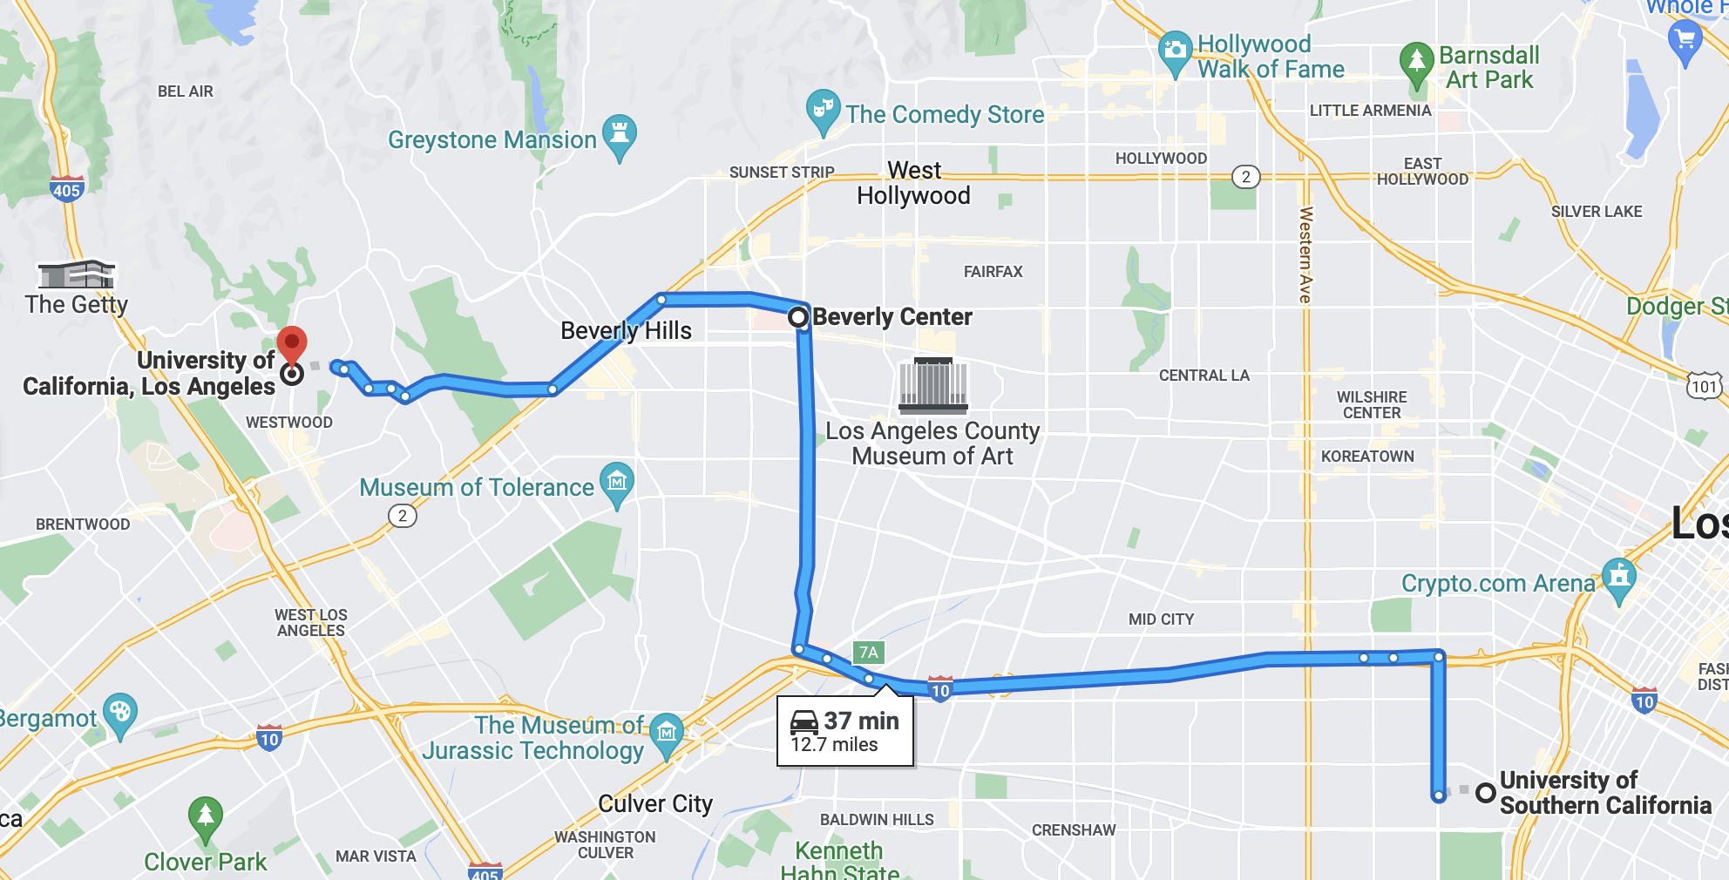

Place Objectives:

Fortis will be placed in Southern California in one of the highest populated cities, Los Angeles. Fortis is going to be located in the middle of two of the most known colleges in California such as University of California, Los Angeles and University of Southern California. Since our target audience is college students we want to be located right in the heart of both these colleges.

Place Analysis and Strategies:

Since Fortis is in the fitness clothing industry they really want to get customers who are in their peak years of fitness and that is when people are in college. Students are usually looking to get in their best shape because it is usually when their body is the strongest. Locating our company right in between these competitors gives us a huge advantage to getting customers from both universities (CI #27). University of California, Los Angeles has roughly 45,000 students and University of Southern California has 44,000. With us being right in the middle of these two companies we are in a perfect spot to almost 100,000 customers, granted not everyone is into fitness, but even if you take half of that we would still be in for a great opportunity. Another great opportunity for us is this location would be in the Beverly Center, which is a well-known shopping mall for customers especially tourists. This would lead us to always bringing in new customers even if they aren’t from the area.

If my company Fortis were to move 2 miles in any direction there would be an impact for us. The reason behind this is that our customers are mainly coming from these universities and if we moved closer to one than the other it might arise conflict in our customers and make them think we are more their rival. Since, these colleges are rivals we don’t want our customers to think we are favoring one more than the other. We want to be able to stay right in between both so these universities cannot feel like there is favor towards one more than the other.

Why?

Our main priority for our target audience is college students so our best available option especially in Southern California is to be located between the two biggest universities in that area. Customers are always wanting a convenient shopping experience and us putting our store in a spot where they can easily navigate to and also shop at other stores in the shopping center it will drive them into our store (WS #16; CI #8, 9, 10, 12). Being located in the Beverly Center is a big attraction for us because of the heavy foot traffic that the city of Beverly brings. Beverly is a main attraction for tourists as well since Hollywood is nearby and this also brings in new customers who may not have had a shopping experience that they would get with Fortis.

D6. Non-Digital Promotion Objective(s), Analysis and Strategies Discussion

Non-Digital Promotion Objectives:

Just like the two competitors that I chose for this project my company, Fortis will have some of the same goals such as creating brand awareness and create non-digital promotions to attract my target audience.

Non-Digital Promotion Analysis and Strategies:
A. New/ Acquisition Strategies:

After doing my research from my two competitors I have found that signage plays a huge role in these companies’ success in non-digital promotion. For example, I want my company’s logo to have 3D signage that will pop to the customers eye. The reason I chose this is because it is a newer look to customers and with our customers being young college students we want something that looks new and young. My competitor #2, Vuori did this and the way they used signage was a huge success. My company Fortis wants to use 3D designs because it will attract customers because it is appealing to the eye. Our colors our navy blue and light blue, which is two colors that work well together and appealing for customers.

Another way that my company will use non-digital promotion is through our influencers. Influencers will be a huge opportunity for Fortis because we are going after college students and athletes (CI #29). Our plan for influencers is to reach out to some of the best college athletes in the colleges nearby. The reason we want to do this is because if a student for example goes to University of Southern California and we get the Quarterback from the football team it will easily attract them into our store. This will also spread the name of our company because these big athletes are already creating a big fan base, even around the world and it can easily get our name out there as well. Influencers will be one of the best non-digital promotion opportunities for us because it will make students from these universities feel that they can trust us because we are already apart of some of their “family.”

The last option for non-digital promotion that we would want to use is setting up events at the local university. An opportunity for this would be to collab with University of Southern California and University of California, Los Angeles and see if they would let us set up a booth at their sporting events. This would be a big opportunity for us because we could set up booths at tailgates and have customers come play fitness games and see our product as well. This would be a great option to show our products and having fun activities for our customers to be a part of, while they are killing time waiting for the game they are there for starts. We would have giveaways, prizes and promotions at these booths for customers to have a fun time and be rewarded for spending time with us. This would help Fortis build their brand awareness and start getting their name out to the target audience we are looking for.

B. Existing Customer Strategies:

A great way to keep my customers coming into my store for the long-term is creating ambassador programs. Throughout my research on my two competitors I have found that ambassador programs have been a huge hit for companies and making sure their customers have a reason to come back. For my company I want to give out an ambassador program to athletes or anyone working in the fitness industry. Our prices are already lower than the industry average so I don’t want to give the ambassador program out to everyone. If we can give these out to athletes and anyone in the fitness field we will easily be able to keep these customers long-term. We will be offering a 25% discount if you are in the fitness field and it can be used for any purchase. We want our customers to feel that they are important shopping with us and being involved in our community is a huge way for them to feel this and want to comeback.

Another existing customer strategy I have seen occur is being involved with the community. Being involved with the community is a huge way to impact our customers because it shows that we care for them and aren’t in it for the money. Since our company is about targeting college students we will really want to make an impact on them. By us coming out to some of their top sporting events it will build relationships with these customers. Putting on fundraiser events to build money to college students who can’t afford school would be a great way to build love within our company. I would want to half fundraisers for this at games and be able to draw a winner to win a scholarship if the school allows it. By attending these events we will be able to build a strong trust between our customers and be able to have them come in for the long-term in our store.

The last option I have found for existing customer strategies is putting a gym into Fortis’s clothing store. This is my favorite option and I feel could be our most beneficial because it is an easy way to bring customers into our store. I want to have memberships that can be bought and it will provide discounts and upcoming news that are exclusive to the customers apart of this membership. This would be beneficial because customer’s nowadays always want to be the first to know because they want to feel like they are a part of something and this would be a perfect opportunity. The gym in our store is the best option because it brings in customers to work out and we heavily press that we want our customers to have a healthy lifestyle. This would be a great place to start especially with our store college themed it will make the customers feel welcomed and want to work out, instead of it feeling like a drag. I feel this will also be a viable option because almost all the people working out in there will be college students so it’s a great way for the customers to make friends and have a fun time. A way that we will reward our customers for coming in and using our workout center is if they do a certain number of workouts in a month they will be rewarded a free item depending on the month. This will easily attract customers to come back in and stay shopping and working out with us.

Why?

Fortis aims to build a community around their store and bring in customers that will feel welcomed into our store. By providing ambassador programs they will feel like a family and continue coming into our store. With us reaching out to college students and providing options and giveaways for them it will show that we care for them. Also, with us having a workout center in our store it will give a great opportunity for customers to come in and get a workout in and have a great experience.

D7. Digital Promotion Objective(s), Analysis and Strategies Discussion

Digital Promotion Objectives:

Fortis has strong methods using digital promotion in order to increase brand awareness. Fortis is able to do this by using technology, social media and other methods to engage their customers to come in and get the best experience possible.
Digital Promotion Analysis and Strategies:
A. New/ Acquisition Strategies:

A great way for Fortis to be involved with digital promotion is through the use of social media apps. This is one of the most used digital promotion methods because it is one of the easiest ways to reach out to customers. For instance, since my two competitors have been around longer they have a couple million followers on these apps. By creating a fan base like this it is such an easy opportunity to reach out to customers and get instant feedback. By making a post it can make it easy for customers to see without even getting out of their house. By being on social media it is also an easy method to reach out to a certain group of people. Since our main goal is to attract college students we want to be sponsored around their pages. This will give us the biggest jump to get involved on social media and grow our customer fan base (CI #30). By giving out ambassador programs and NIL deals to college athletes it gives us a huge amount of room to grow because these athletes will have to post about us in their clothing and it will reach a huge amount of people at the University they attend.

Being on social media and creating a fan base it will require us to have a working website that is extremely convenient for customers to use. Customers are going to see our athletes we sign post about our products and are instantly going to see what we have online, before they step foot in the store. This is because customers want to have the most convenient shopping experience, and if they are new to our company they are going to want to see what’s online before coming in to see what type of products we sell and if they will even be interested. This is where Fortis can succeed because we will have a convenient website with our products being showcased for these customers. We would have a background of how we started and why we do what we do so customers can see that we aren’t just about selling products, we want them to see our passion. This will help engage the community and build loyal customers.

B. Existing Customer Strategies:

Fortis wants to be able to reward customers for following them on social media, by doing this we want to offer them a 10% discount for their first follow on social media. This is a good way for us to get customers into our store or purchasing products online. The next step to this for keeping existing customers is then providing a newsletter for them. Customers can sign up with their email and receive upcoming news about new products and also get updated on upcoming promotions. This will only be for our subscribers so it will make them feel like family and keep them coming in.

The next option that will help us keep existing customers is have a review page on our website. I feel my two competitors have lacked this and made it hard to find, but why not have our customer feedback be easily accessible so we can make changes when they are needed. When customers see that you listen and make changes towards their suggestions it leaves them nothing, but satisfied. Fortis is all about customer service and by listening to our customers and providing instant feedback on our website it will show we have nothing to hide and are interested in their suggestions to make our company even better.

Why?

Since Fortis’s goal is to reach out to college students there is no better way to doing this than online. Almost all college students are on some form of social media or using online shopping so it is our best benefit to reach out to them through that. We are focused heavily on social media because that is where the biggest form of promotion is right now and is a must to stay in competition. Also, by using social media it brings customers to our website so we need to have it very convenient so our customers can get a great first experience and want to continue shopping with us for the long-term.

Section E: List of Works Consulted

Articles

Article #1:
Baeza and Quinn. “Transforming the Fashion Industry by: The Evolution of Design & Merchandising Education.” Pages 197-206. December 1, 2021.
Relevance:
Breaks down the code of ethics in the clothing industry. It talks a lot about how ethics is simply making the correct decisions, and with any company that should be everyone’s goal. Every employee should know the code of ethics and if they don’t you are going to see that broken over and over again.

Article #2:
Jaworek. “Source of Success of the most Valuable Sportswear Brands in the World.” Pages 1050-1055. April 2, 2021.
Relevance:
The author broke down a lot of data for the most successful sportswear industries. It broke data down from 2006 and 2020, which provided a huge change in where companies started and now are at.

Article #3:
Hepburn, “In Patagonia (Clothing): A Complicated Greenness.” Page 636. November 1, 2013.
Relevance:
This article had a section about their “environment policies and practices.” Every employee can take up to two months to go on a paid internship with the company that is related to environmental ideals of the company. It talks a lot about “going green.”

Article #4:
Salpini, “Vuori doesn’t need the $400M it just raised. How founder Joe Kudla approaches scale, profitably.” November 2, 2021.
Relevance:
Vuori just raised $400M for their company. Founder Joe Kudla talks about how the money he just raised he doesn’t need it in order to still go along with his growth strategy. Kudla didn’t make Vuori like other fitness clothing brands, he wanted to make a company that was different than the others.

Article #5:
Thomas, “Lululemon aims to double sales to $12.5 billion by 2026, eyeing even bigger men’s business.” April 20, 2022.
Relevance:
Lululemon’s plan to grow even bigger in the next couple of years. Lululemon plans on growing their men’s business. They believe that product innovation, customer experience and market expansion can give them more of a boost than they already have. The main focus as of right now is the men’s businesss since many people think of Lululemon as a women’s clothing brand. Lululemon’s goal is to double its men’s revenue.

Article #6:
Beausoleil, “Vuori: How a SoCal Brand Grew to a National Market” April 16, 2021.
Relevance:
This company was founded in 2015 and has showed much growth since. In 2019 they raised around $45 Million in growth equity. They focus a lot of their clothing on yogis, surfers, and lifters. They made the apparel modern cuts and to remain stylish, often “infusing west-coast vibes in designs.” They wanted to make the product durable, flexible, moisture-wicking, and odor resistant.

Article #7:
Deer, “Lululemon Launches Omnichannel Fitness Membership” October 4, 2022.
Relevance:
Lululemon announced a new membership program tied into its most technologic product they sell, which is their mirror. In 2022, Lululemon bought “fitness screen MIRROR” for 500M. Their plan was to merge experiential retail and at-home workouts.

Article #8:
Lowe, “Vuori Launches in Asia, Mexico, and the Middle East as International Expansion Continues” September 28, 2022.
Relevance:
Vuori is moving their company along at a rapid pace. They are still a new company, but they have expanded international now to China, Singapore, Mexico, Hong Kong, and the Middle East. Vuori believes that in order to further the brands growth and profitability, they needed to expand outside of the United States.

Article #9:
Wight, Michael, “What Impact do Counterfeits Have on the Fashion Industry?” October 15, 2022.
Relevance:
This article showed relevance by giving precise examples of how counterfeit products can strongly hurt a company. It can also hurt the economy because of health hazards. Counterfeit products provide you with no trust in customers.

Article #10:
Cho, Renee, “Why Fashion Needs to Be More Sustainable” June 10, 2021.
Relevance:
This article provided me with some strong data on how fashion could be more sustainable. It shows how we can improve the overall make of products and how we can do less to harm to the environment.

Article #11:
Avada Blog (no author), “Lululemon Marketing Strategy: How To Thrive In A Saturated Apparel Market” June 16, 2022.
Relevance:
This article was very relevant for my target market project because it gives insight of how Lululemon markets to their target market. It talks about price, place, and promotions. It shows the digital and non-digital tactics they use as well.

Websites

Website #1:
https://shop.lululemon.com
Last Viewed: September 9th, 2022
Brief Description: This is my first competitor so it was beneficial to see how their website works. I noticed when looking through their website that they don’t try to hide any information. Lululemon definitely wants you to see their story and see what they are doing now to stand out in society.
Relevance:
They have ambassador programs for almost anything you can think of. They also talk about 4 programs curated to support everyone’s one purpose: to realize the full potential within every one of us. These 4 programs are wholesale, Studio Essentials, Corporate, and Team Program.

Website #2:
https://vuoriclothing.com
Last Viewed: September 9th, 2022
Brief Description: This is my second competitor. While looking through their website I noticed how it was all about that “California vibe.” This included surfing mainly, and mainly a beach look.
Relevance:
Investment in happiness more than product guarantee and commitment to experience for customers. Their guiding principles that they share are -aim to make great products, be in great relationships and live extraordinary lives.

Website #3:
https://www.yelp.com
Last Viewed: September 9th, 2022
Brief Description: I looked up the Lululemon at Irvine Spectrum. This store had 3 stars and a 4 price.
Relevance:
Workers tend to talk with each other than help customers. Clothing fits well/ very comfortable. When workers do help they do a great job in finding sizes that fit. Clothing is overall great for workouts.

Website #4:
https://www.yelp.com
Last Viewed September 9th, 2022
Brief Description: I looked up Vuori at the Irvine Spectrum location. This store had 4.5 stars.

Relevance:
They had great personal interactions with customers, but employees have had inappropriate conversations thinking that some of the customers couldn’t hear them. Clothing was found to be nice for both genders

Website #5:
https://www.gymshark.com
Last Viewed: September 17, 2022.
Brief Description: They had some of the same names for instance “Sweat collective.” In their website it was really hard to find anything talking about their company, which I found very odd. It was mainly blog’s that they have posted, but nothing of their background.
Relevance:
They have a very small portion of their website talking about their product, but nothing compared to my two companies I am looking into. I found it beneficial because they do a lot of things similar to my companies, but it shows how much the two I’m looking at provide for customers. They didn’t seem to talk much about satisfying customers at all.

Website #6:
https://www.aloyoga.com
Last Viewed: September 17, 2022
Brief Description: Their website was really easy to navigate and made it very easy to find more information about them. Something I thought was cool is they have a tab where you can get yoga classes. They mainly focus on yoga, but they do have some street wear and they call this “Studio-To-Street Sweet.”
Relevance:
Alo definitely targets people who are into yoga, which might steal customers from my two companies I’m focusing on. I noticed that their products are priced almost exactly the same as Lululemon’s.

Website #7:
https://www.tracksmith.com
Last Viewed: September 17, 2022
Brief Description: They are in the fitness clothing industry and they focus mainly on runners. they are in the fitness industry as well, but they have a different perspective as the two companies I’m looking into. They target mainly runners, and on their website, it even says “the goal of the Tracksmith Foundation is simple yet ambitious: to give more people the opportunity to participate in Track & Field
Relevance:
It didn’t really show any other sides of the clothing than just besides running. It helped show that not all fitness industries are focusing on all types of fitness, this one was based on running and Alo was based off just yoga mainly. It shows how well they try to find a target market and stick with it.

Website #8:
https://mpgsport.com
Last Viewed: September 29, 2022
Brief Description: The pictures they have used show people working out and just wearing their clothing as daily wear. There products tend to be very versatile.
Relevance:
MPG has a very similar website to my two competitors. They showcase fitness clothing, but more of a casual type of fitness clothing. On their website you tend to see a lot more women than men, which might entail that they focus more on women products.

Website #9:
https://www.nike.com
Last Viewed: September 29, 2022
Brief Description: They seemed to keep their website very organized, where you didn’t just get thrown items at you like some of the previous websites. Nike seems to always put their newest products on display first and then you can find the rest of the items elsewhere.
Relevance:
This website is useful for me because it helps me see what a top competitor is doing, other than newer companies such as the ones I am looking into.

Website #10:
https://www.adidas.com/us
Last Viewed: September 29, 2022
Brief Description: I noticed how Adidas puts a section on the home screen dedicated just to sizing. I thought that was pretty unique because I haven’t seen a company do that yet as one of the first things you see. They also have their story of the company on the display page as well.
Relevance:
This is beneficial to my TMP because Adidas is once again another top competitor and I wanted to compare them to Nike to see what two of the biggest fitness clothing industries are doing in order to compete with each other.

Website #11:
https://www.grandviewresearch.com/industry-analysis/activewear-market-report
Last Viewed: October 4, 2022
Brief Description: Activewear market size data base. Gives us multiple data points that can show the growth of this industry.
Relevance:
This helped my TMP project because it gives an exact price of the industry that I am researching and provides evidence around that.

Website #12:
https://www.macrotrends.net/stocks/charts/LULU/lululemon-athletica-inc/number-of-employees
Last Viewed: October 4, 2022
Brief Description: The data in this website shows us how the number of employees have increased over the last couple years in Lululemon’s company.
Relevance:
Provides an exact percentage each year of the increase of employees for Lululemon. This helps show how much the company is growing.

Website #13:
https://www.statista.com/statistics/243199/number-of-employees-of-nike-worldwide/
Last Viewed: October 9, 2022
Brief Description: This website shows the number of employees that worked at Nike over the last 10+ years. Giving us insight of how the company has grown.
Relevance:
This provides me with feedback that when there is growth in a company it usually leads to them expanding, which then makes you need more employees. It makes it a continues cycle.

Website #14:
https://www.dynamicteamsports.com/athletic-apparel-technologies/
Last Viewed: October 12, 2022
Brief Description: This website talks about the changes in technology with fitness clothing and different ways that we are able to change up products.
Relevance:
This is relevant because it can show us a way that we can change our company, while technology is changing at the same pace. We must be aware of these changes to get the most out of our products.

Website #15:
https://worldpopulationreview.com/us-cities/newport-beach-ca-population
Last Viewed: November 6, 2022
Brief Description: This website gives the population of Newport Beach, California.
Relevance:
This is relevant because Vuori is located at Fashion Island which is located in Newport beach.

Website #16:
https://www.irvinecompany.com/press-release/50-years-of-fashion-island/
Last Viewed: November 6, 2022
Brief Description: This website talks about 50 years of Fashion Island and gives statistics on the shopping center.
Relevance:
This is relevant because it shows how many people visit Fashion Island shopping center in a year.

Website #17:
https://justwalkout.com
Last Viewed: November 8th, 2022
Brief Description: This website shows a new technology for a faster checkout for companies. Created by amazon they allow customers to scan a credit card coming in and be able to walk out with a product and not wait in a line to checkout.
Relevance:
This is relevant for my TMP project because it gives me an idea for my third business to incorporate new technology in order to shorten a wait time for my customers. This shows to provide a convenient shopping experience.

Website #18:
https://www.statista.com/statistics/291231/number-of-lululemon-stores-worldwide-by-country/
Last Viewed: November 22nd, 2022.
Brief Description: This website shows data of how much Lululemon has grown in the past couple of years. It shows how many stores were opened in all the countries it is in and shows the increase in the last four years.
Relevance:
This is relevant for my TMP project because it shows how fast the company has grown especially from country to country. Lululemon has shown a huge growth in expansion and is why their company is on the rise. This will help me show how well the company is doing in the fitness clothing industry.

Website #19:
https://exposureninja.com/blog/lululemon-marketing-strategy/
Last Viewed: November 26th, 2022.
Brief Description: This website gives insight on how Lululemon promotes themselves through digital promotion. It gives data of engagement rates and shows the number of followers they have on each platform.
Relevance:
This is relevant for my TMP because it gives me data of engagement rates and shows averages for the industry and Lululemon by itself. It shows the number of followers they have on social media platforms and also some of their competitors. It also gives a background of the company and how they got to where they are today.

Website #20:
https://finance.yahoo.com/news/lululemon-athletica-inc-nasdaq-lulu-110234484.html
Last Viewed: November 26th, 2022.
Brief Description: This website talks about where Lululemon is as a company. It shows their return on equity and gives us knowledge about their growth.
Relevance:
This is relevant for my TMP because it gives me insight on Lululemon and shows how they have grown over the past couple of years.

Professional Interviews

Professional Interview #1
Male Sales Associate at Vuori, Fashion Island. The employee has worked there for 6 months. September 24th, 2022
Relevance:
They stated that because of high prices at their store and even other competitors that they actually don’t do much shopping. This information was relevant to my TMP because it got me to think more about how pricing can affect even the workers.

Professional Interview #2
Male Sales Associate at Vuori, Fashion Island. The employee has worked there a little over a year. September 24th, 2022.
Relevance:
This employee was more to the point so I didn’t get much out of him, but still go the basic questions answered. He talked to me about why he wanted to work at Vuori and it was because he felt it suited California well as a clothing brand, and he liked the surf vibe it gave.

Professional Interview #3
Women Sales Associate at Lululemon, Cerritos Mall. The employee I talked to has worked there for about a year. September 25th, 2022.
Relevance:
She talked about how she worked at Lululemon because she has been getting into yoga the last couple years and she thought the brand really represented yoga well.

Professional Interview #4
Women Sales Associate at Vuori, Irvine Spectrum. She has worked there for about 4 months. October 8th, 2022.
Relevance:
She said that her previous job was working at Vans, but she didn’t get enough hours so she had to find another job. Vuori has been much better at giving her hours to get more money. She decided to work at Vuori because of the up and coming name, and she fell in love with their clothes. She also says that they are a very sustainable company.

Professional Interview #5
Women, Sales Associate at Vuori, Irvine Spectrum. She has worked there for 8 months. October 8th, 2022.
Relevance:
I first asked how she felt she was treated by her manager. She said that they have been very patient with her especially when she was first hired, and they are also very understanding of your personal life outside of work.

Professional Interview #6
Women, Sales Associate at Lululemon, Irvine Spectrum. She has worked at Lululemon for roughly a year and a half. October 8th, 2022.
Relevance:
She explained to me how she really likes the diversity of the company and how much they do for the community. Lululemon is a brand that is perfect for everyone no matter what type of activity they are doing. You can wear the clothes for all occasions and that is why she feels the company has had so much success.

Professional Interview #7
Women, Manager at Vuori, Irvine Spectrum. She has worked at Vuori for 2 years. October 15th, 2022.
Relevance:
I had a great experience talking with one of the managers that gave me quality insight on the company. She has met the owner and got ton share her experience with me about why he was inspired to create Vuori.

Professional Interview #8
Women, Sales Associate at Lululemon, Fashion Island. She has worked at Lululemon for a little less than a year. October 20th, 2022.
Relevance:
The worker talked heavily on their focus of keeping the store very organized. She said how sometimes it can be exhausting making sure all items are perfectly place in the store to make it appealing for the customers. She knows it is very important and that is why it is heavily focused on.

Professional Interview #9
Myself

Professional Interview #10
Women, Sales Associate at Lululemon, Grove. She has worked at Lululemon for a couple months. November 25th, 2022.
Relevance:
This worker talked to me about how they can struggle with wait times especially with how busy this Lululemon location is. I went in on Black Friday and it was packed and she said she wishes that they had a better system because it was a non-stop line.

Customer Interviews

Customer Interview #1
I interviewed my roommate (Male) who made a purchase at Lululemon as we went there for my professional interviews. I interviewed him on September 25th, 2022. The interview took place at Cerritos mall.
Relevance:
He didn’t plan on purchasing anything at the time of being there, but when he was looking around the store he saw the clearance rack and found really good deals. I asked how his shopping experience was, and he said how it was really easy to find things you don’t even plan to look for. He felt their normal products can be on the expensive side, that is why he leaned to the clearance rack.

Customer Interview #2
I interviewed one of my roommates (Male) on Lululemon. This interview took place at my home. September 25, 2022.
Relevance:
His first thought for when I asked about his last experience at Lululemon he stated how much he loved their music choice, which put him in a mood to shop. He went straight to the clearance rack, because he feels the prices can be too high for the quality, and he doesn’t value it enough to buy at full price. His interaction with the workers was that they were very short with him. He felt as a shorter man the shirts wouldn’t fit him properly because of the length and that is another reason he doesn’t want to pay full price.

Customer Interview #3
Women, I interviewed a customer at Lululemon. This interview took place on October 8th, 2022 at Irvine Spectrum.
Relevance:
The women I went up and asked about was the product she was planning to buy. She stated that for all of her workout attire, Lululemon stands out the most. She said the comfort of the clothing is unmatched between other brands. She was buying running shorts.

Customer Interview #4
I interviewed my girlfriend. I interviewed her about Vuori. It took place at home. I interviewed her on October 8th, 2022.
Relevance:
She said that Vuori is more sustainable company and feels that they are better for the environment. She also said that she likes their products more Lululemon because Vuori fits her better, and Lululemon is harder to get clothes that fit her style. She likes Vuori’s more athletic clothes rather than Lululemon’s because they can be more casual at times.

Customer Interview #5
Male, I interviewed a customer from Lululemon. I interviewed him on October 8th, 2022. This interview took place at Irvine Spectrum.
Relevance:
He talked about how their products are so comfortable and he loves to wear them when he works out and goes to play golf. He said employees are very helpful when it comes to getting him a proper size. I asked him if he has ever done in-store pick up where you order online and pickup in store. He said he has and that its very convenient when he doesn’t feel like going shopping all day, it was a very smooth transaction.

Customer Interview #6
Male, I interviewed a customer at Alo. I interviewed him on October 15th, 2022. This interview took place at Fashion Island.
Relevance:
He stated that he has never been a fan of shopping at big name companies, since Lululemon has grown so much over the years. He feels the employees at these not as well-known companies are much more helpful, because they are driven to improve their company, while a company like Lululemon has already gotten so far.

Customer Interview #7
Male, I interviewed another customer at Alo. I interviewed him on October 15th, 2022. This interview took place at Fashion Island.
Relevance:
This customer talked mainly about how he never really saw much of a difference between Lululemon and Alo, as most of their products look and feel the same. He said he shops at both and was just looking to see if anything different came up when going into both stores.

Customer Interview #8
Male, I interviewed a customer at Vuori. I interviewed him on October 15th, 2022. This interview took place at Fashion Island.
Relevance:
This customer really dug deep on talking about the appearance of the store rather, than the products they were selling. He talked about how clean and organized Vuori is right when you walk in. He said most stores clothes can be everywhere and it is almost overwhelming as a shopper, but at Vuori he said he can come in and find exactly what he is looking for without scrolling through every product to find a hidden gem.

Customer Interview #9
Women, I interviewed a customer at Vuori. I interviewed her on October 20th, 2022. This interview was at Fashion Island.
Relevance:
This customer talked about how clean the store is and how well organized it is. It brings off a homey vibe especially being from California.

Customer Interview #10
Women, I interviewed a customer at Vuori. I interviewed her on October 20th, 2022. This interview was at Fashion Island.
Relevance:
This customer talked about how convenient this store is and how she always makes a stop in when she comes to the mall. She feels employees make her feel welcomed. The clothing products can be casual or athletic, which she loves.

Customer Interview #11
Male, I interviewed a customer at Vuori. I interviewed him on October 20th, 2022. This interview was at Fashion Island.
Relevance:
This customer talked about how the prices at Vuori are usually on the more expensive end. He knows that the quality of the product is really well put together so it makes the purchase worth it.

Customer Interview #12
Male, I interviewed a customer at Vuori. I interviewed him on October 27th, 2022. This interview was at Fashion Island.
Relevance:
This customer talked about his experience with the vibe of the store. He is from California and has surfed his whole life and he feels welcomed at Vuori. He loves the surf decorations and the look of the store when he walks in.

Customer Interview #13
Male, I interviewed a customer at Lululemon. I interviewed him on October 27th, 2022. This interview was at Fashion Island

Relevance:
He talked about how Lululemon has a distinct layout in their store. It is almost always women on the left, men on the right, fitting rooms in the back and accessories by the registers. He talks about how the store is never messy and you don’t feel overwhelmed when coming in.

Customer Interview #14
Women, I interviewed a customer at Lululemon. I interviewed him on October 27th, 2022. This interview took place at Fashion Island.
Relevance:
She talked about how employees were knowledgeable about the products. She came in looking for new running shorts because she wanted to start jogging. They actually steered her away from certain ones she was looking at because they had ones that were specifically what she was looking for.

Customer Interview #15
Women, I interviewed a customer at Vuori. I interviewed her on October 27th, 2022. This interview took place at Fashion Island.
Relevance:
She talked about how the employees were very helpful with her purchase. She told me how she always walks her dog around the beach so she was looking for joggers for the cooler mornings. The employees were very helpful with finding the right fit for her.

Customer Interview #16
Women, I interviewed a customer at Vuori. I interviewed her on November 2nd, 2022. This interview took place at Fashion Island.
Relevance:
This customer talked about how she shops here because of how Vuori products are made. She actually has a friend who works there and she told her that they are making products to help the environment (recycling).

Customer Interview #17
Male, I interviewed a customer at Lululemon. I interviewed him on November 2nd, 2022. This interview took place at Fashion Island.
Relevance:
This customer talked about the prices and how he feels they can be a tad expensive, but the quality can make it worth it in the long-run.

Customer Interview #18
Male, I interviewed a customer at Vuori. I interviewed him on November 2nd, 2022. This interview took place at Fashion Island.
Relevance:
I talked to this customer about pricing as well. He talked about almost the same things as my last interview. Prices can be expensive, but the quality is really nice. He says it fits his personality as well and that is why the purchase is worth it.

Customer Interview #19
Women, I interviewed a customer at Lululemon. I interviewed her on November 2nd, 2022. This interview took place at Fashion Island.
Relevance:
The customer I talked to shared how convenient this this Lululemon’s location is in. It is perfect for his shopping experience because it is in a mall where he can shop at other stores as well.

Customer Interview #20
Male, I interviewed this customer at Lululemon. I interviewed him on November 2nd, 2022. This interview took place at Fashion Island.
Relevance:
This customer talks about how the shopping experience can be hit or miss. Employees are either really helpful or not at all. Standing around chatting happens a lot.

Customer Interview #21
Women, I interviewed this customer at Lululemon. I interviewed her on November 7th, 2022. This interview took place at Fashion Island.
Relevance:
The women I interviewed explained to me how she was coming in to return a product. She said the process wasn’t organized at all and didn’t go as easy as planned. She felt that some of the employees aren’t understanding. They felt embarrassed when holding up the line.

Customer Interview #22
Women, I interviewed this customer at Vuori. I interviewed her on November 7th, 2022. This interview took place at Fashion Island.
Relevance:
This woman talked about how the service at Vuori has been phenomenal. She has come in and has always got great customer service, whether it is buying a product or returning. The employees have been very knowledgeable towards their products.

Customer Interview #23
Male, I interviewed this customer at Lululemon. I interviewed him on November 7th, 2022. This interview took place at Fashion Island.
Relevance:
This customer talked about how the wait time for lines can be extremely long at times. Most Lululemon’s only have a few registers so when the line is long they have to wait a really long time. He stated that sometimes he decided not to purchase something because of how long the line was.

Customer Interview #24
Male, I interviewed this customer at Vuori. I interviewed him on November 7th, 2022. This interview took place at Fashion Island.
Relevance:
I asked this customer about wait-times at Vuori. He stated how they do a good job of getting the line through when there is one. He hasn’t had to many problems and he is happy because he is a very impatient person. He has experienced long wait times and hates when a company doesn’t fix it.

Customer Interview #25
Women, I interviewed this customer at Lululemon. I interviewed her on November 7th, 2022. This interview took place at Fashion Island.
Relevance:
This customer talked about how well they do of coming out with a variety of products, not everything is the same, which you would expect in with workout attire.

Customer Interview #26
Women, I interviewed this customer at Lululemon. I interviewed her on November 21st, 2022. This interview took place at Fashion Island.
Relevance:
This customer talked about how Lululemon has sustainable products and she loves how environment friendly they are. She has a friend who works for Lululemon and she has told her all the insights on it.

Customer Interview #27
Male, I interviewed him on November 28th, 2022. This interview took place after a baseball practice.
Relevance:
I talked to one of my teammates and asked how he felt about my company Fortis and the location. My location is by UCLA and USC and he felt it would be nice because it would be convenient for customers to come in from the universities.

Customer Interview #28
Male, I interviewed him on November 28th, 2022. This interview took place after baseball practice.
Relevance:
I talked to one of my teammates about the pricing of my company Fortis and wanted to see if he felt it was reasonable. He felt that the lower prices are really beneficial for my company because he feels it is hard to shop at my competitors because college students don’t have the budget.

Customer Interview #29
Male, I interviewed him on November 28th, 2022. This interview took place after baseball practice.
Relevance:
I talked to one of my teammates about my non-digital promotion ideas. He felt that having influencers for my company would be a big opportunity. He says that he has started shopping at companies based off an influencer because he really like them and wanted to get a part of it.

Customer Interview #30
Male, I interviewed him on November 28th, 2022. This interview took place after baseball practice.
Relevance:
I talked to another one of my teammates and this was about digital promotions. I told him how Fortis wants to give out NIL deals to college athletes in order to spread their name to these top performers at Universities. He thought this was a great idea and he actually has a NIL deal and talks about the benefits of it. He said that the company he has a NIL deal with makes him put their company in their Bio on social media and it is a great way for customers to see this and click on the company and learn about them.

